Vojtěch Mojžíš – for Czech leading magazine OPUS MUSICUM 5-2024

_________________________________________________________________

**The 35th year of Forfest Kroměříž**

On Thursday, July 4, 2024, in the early evening, the 35th year of the international festival of contemporary art with a spiritual focus FORFEST CZECH REPUBLIC 2024 closed in the lecture hall of the Museum of Kroměříž with a concert of electro acoustic music.

What was this year's anniversary year like, what did it bring?

Its core part was 19 concerts, organized mostly in Kroměříž. However, under the Forfest brand, three concerts were also held outside this cultural center in the Haná region this year, one in nearby Kojetín, the second in Hodonín, and the third in Olomouc. The series of nine Conversations on Music took the form of listening lectures, and this year's program also included two musicological lectures. Twenty contributions to the colloquium "Spiritual Currents in Contemporary Art", which was organized as part of Forfest at the Museum of Kroměříž, were mainly musicological.

**1. Concerts**

**With a significant advance from the main event of Forfest 2024, on the afternoon of April 25, a concert by the piano duo Janna Polyzoides (Austria) and Markus Koropp (Germany) took place in the concert hall of the Kojetín Elementary School. Although somewhat disparate in age and gender, the duo played compactly, precisely, passionately, and focusedly.**

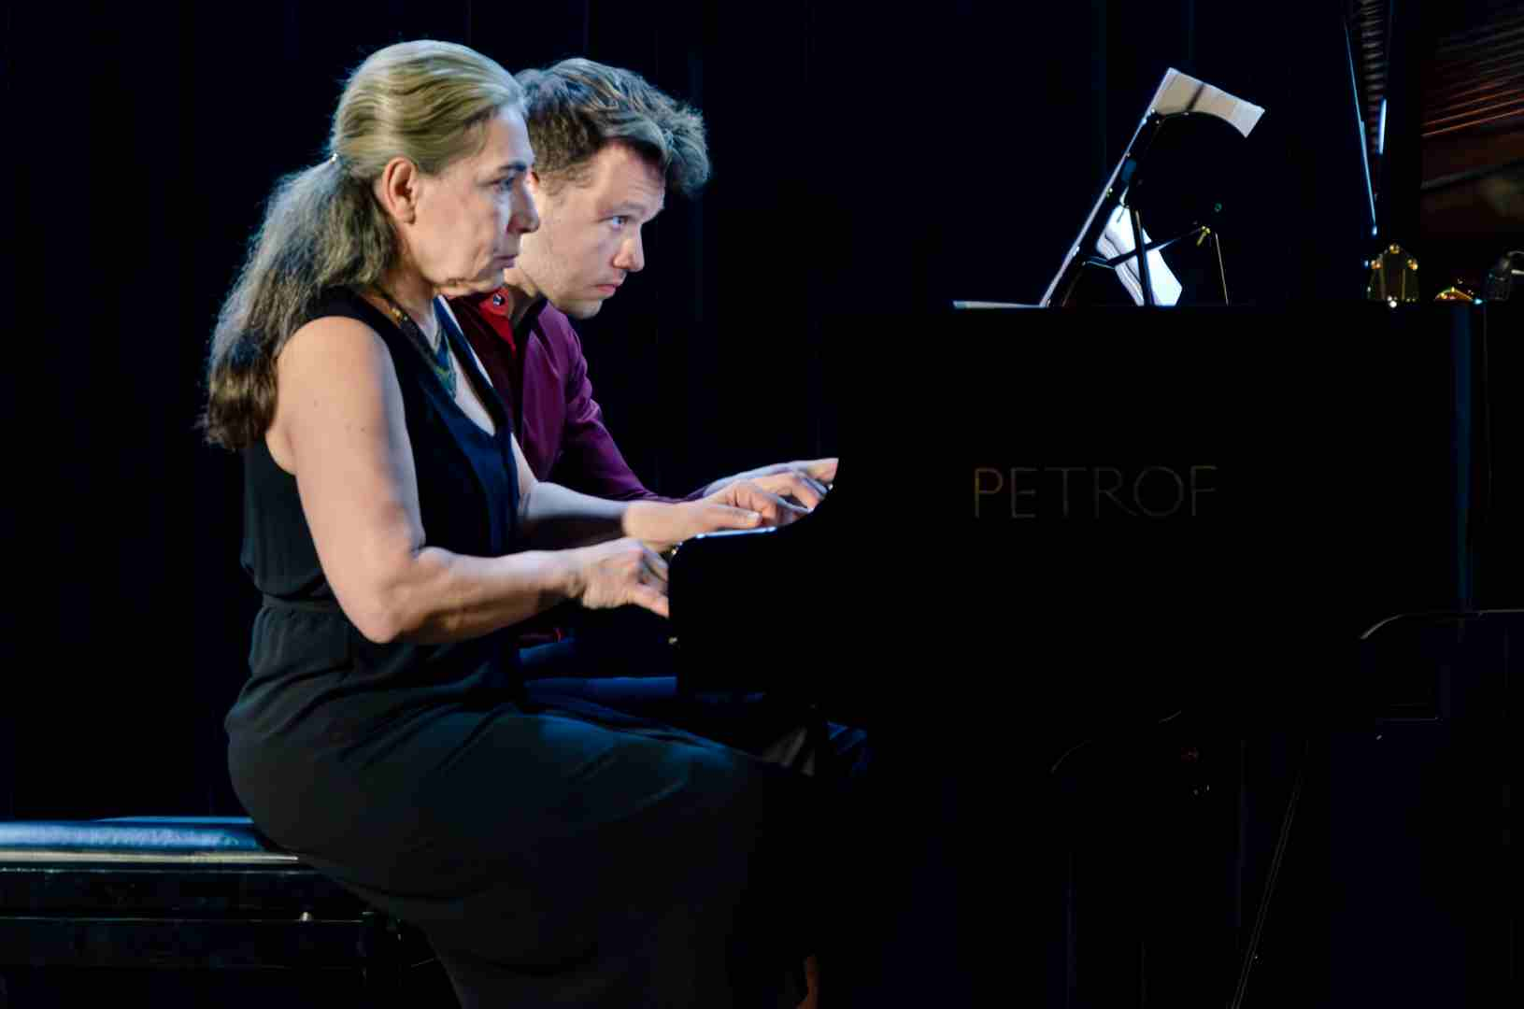

Janna Polyzoides /Austria/ - Markus Koropp /Germany/ foto: archiv festivalu

The artists chose pieces close in character and compositional style to neoclassicism and European New Music of the 1960s. They opened with a four-movement cycle of short contrasting movements entitled Small Suite for 20 Fingers, Op. 61b by Iván Eröd. This was also followed by a neoclassical one-movement brief piece Ecossaisen for piano four hands by Hermann Markus Pressl, a play based on the effect of short motifs, separated from each other by significant pauses as if waiting for an unspoken answer. The third number on the program was Five Pieces for piano four hands “EZLO oder die Vernichtung von Gok”, a cycle by Görgy Ligeti. It begins in a marching tempo, which is suddenly cut short. The second part is polyphonic, four-voice with a gradual onset of voices, ending with a resolute chord. The third is short, burlesque, the fourth lyrically dreamy. The fifth is a cheerful folk song. This was followed by the composition Drásnění by the contemporary Moravian composer Vít Zouhar. The work, at first at a low dynamic level with very economical, almost punctuated means, keeps the listener in constant tension, but it ends with a vigorous arpeggio in forte. The single-movement, internally distinctly structured, four-hand composition Ironien op. 34 by Erwin Schulhoff is characterized by a resolute, motoric onset. The composer here intensively employs all four hands of the performers. The contrasting motoric ostinatos seem to beat time, they are in strong dynamics. Compositionally, it was the highlight of the entire concert. However, its conclusion belonged to the extensive composition Serynade by Helmut Lachenmann, performed by Markus Koropp. It is eruptive, ametrical, full of short expressive ideas, mainly based on timbres, dramatically separated from each other by clustered beats. The performer carefully distinguished contrasting expressions and paid attention to playing precision. However, the composition is too long, its form lacks coherence and any developmental logic.

The second concert of Forfest 2024 took place on the afternoon of Saturday, June 15th, at the Gallery of the Moravian Artists' Association in Hodonín. This is where the Forfest dramaturgy placed the performance of the Trio Euterpe ensemble, consisting of Barbara Tolarová – violin, Štěpán Filípek – cello and Ondrej Olos – piano.

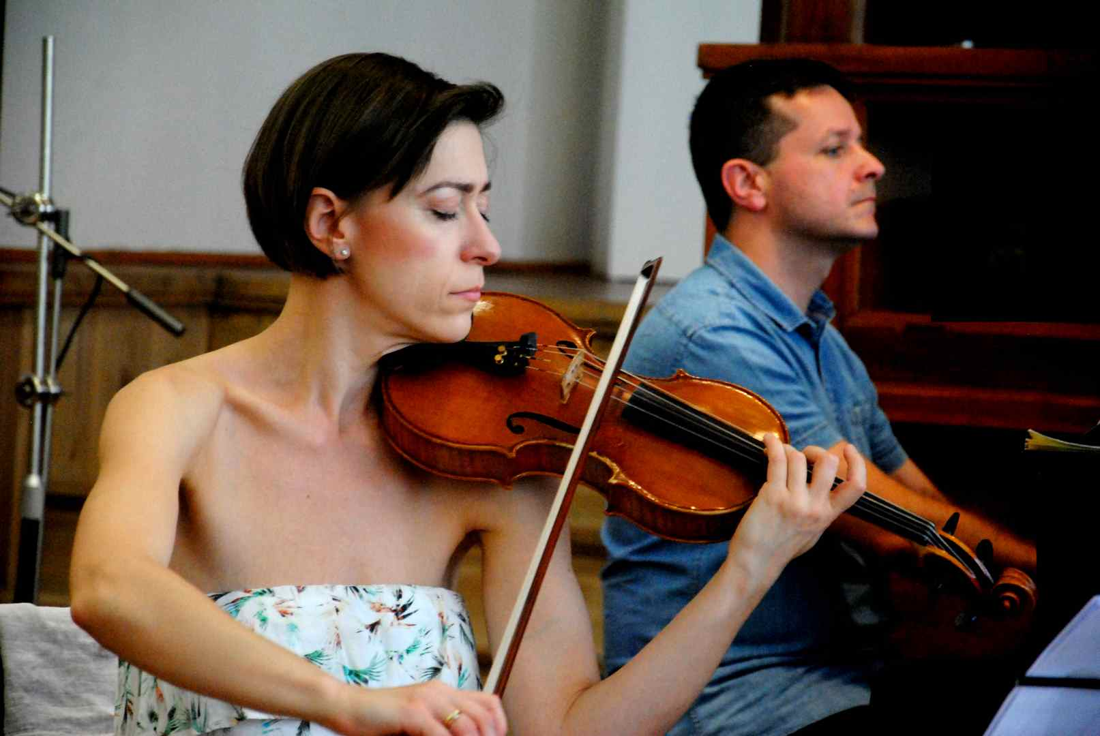

Trio EUTERPE - Barbara Tolarová CZ - Ondrej Olos SK

The artists came up with a well-thought-out dramaturgy. At the beginning, they included Two Meditations for Solo Cello (The Secret Path, The Gift) by Vojtěch Mojžíš. This was followed by the famous Piano Trio in G minor by Bedřich Smetana, as a reminder of the ongoing four-year Year of Czech Music. After a short break, in the second half of this hot South Moravian Saturday afternoon, a similar dramaturgical set-up was heard as in the previous part, i.e. first a composition for solo cello - Martin Smolka: Like Ella, then the entire ensemble with a performance of the monumental Piano Trio by Dmitri Shostakovich.

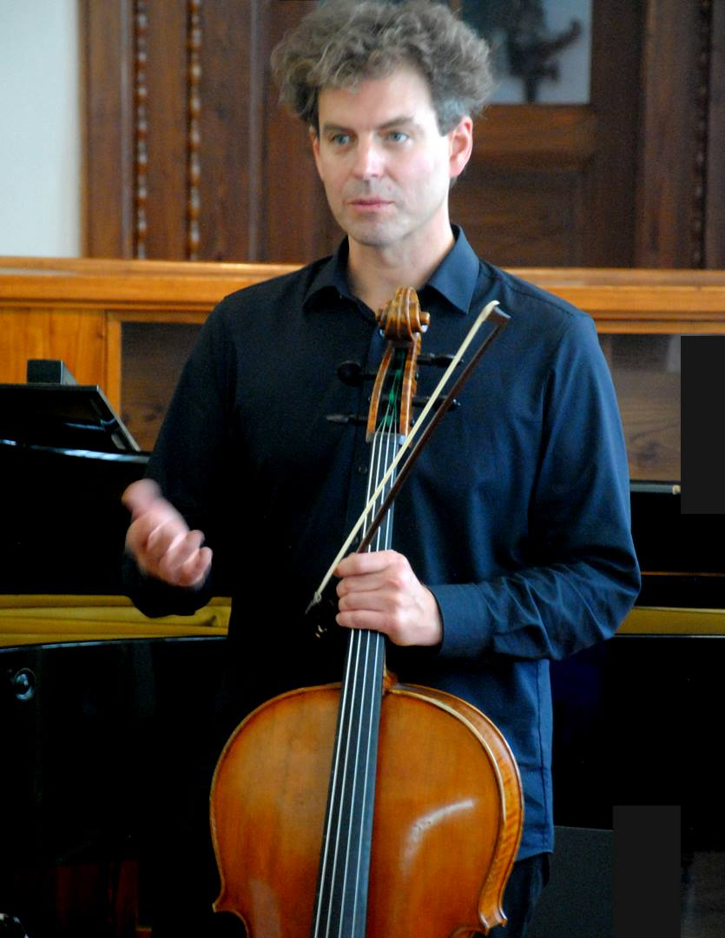

Trio EUTERPE 2024 - Štěpán Filípek

Mojžíš's diptych is composed of meditations originally created entirely independently. In both cases, these are intimate statements, sequences of contrasting thoughts arranged into logical wholes. Filípek performed the work with extraordinary enthusiasm, taking advantage of the opportunity to emphasize sharp contrasts, the polarity of subtle, delicate emotionally tense passages on the one hand and bravura, almost brutal eruptions on the other. The performance of Smetana's chamber work was characterized by urgency and verve. The listeners were immediately strongly impressed by the introductory, deeply felt violin solo. With its dense color and intensity, it foreshadowed a well-chosen interpretative interpretation of the entire three-movement cycle. Martin Smolka dedicated his brief piece to the memory of the legendary jazz singer Ella Fitzgerald. In his composition, he focused on ingenious work with a limited selection of delicate flageolet doublets in contrast with energetic unisons. The soloist played all the ingeniously chosen flageolet combinations sonorously and with complete confidence. Shostakovich's chamber work created a contrast, a counterpoint to the similarly conceived trio of Smetana. While Smetana expressed himself stylistically with the pure means of Romanticism, in Shostakovich we find a whole mixture of hints of stylistic development trends of musical thought of the mid-20th century, ranging from expressionism to neoclassicism, from tragedy and pathos, to hints of sarcasm. All this was duly emphasized by the artists in their concentrated and captivating interpretative performance.

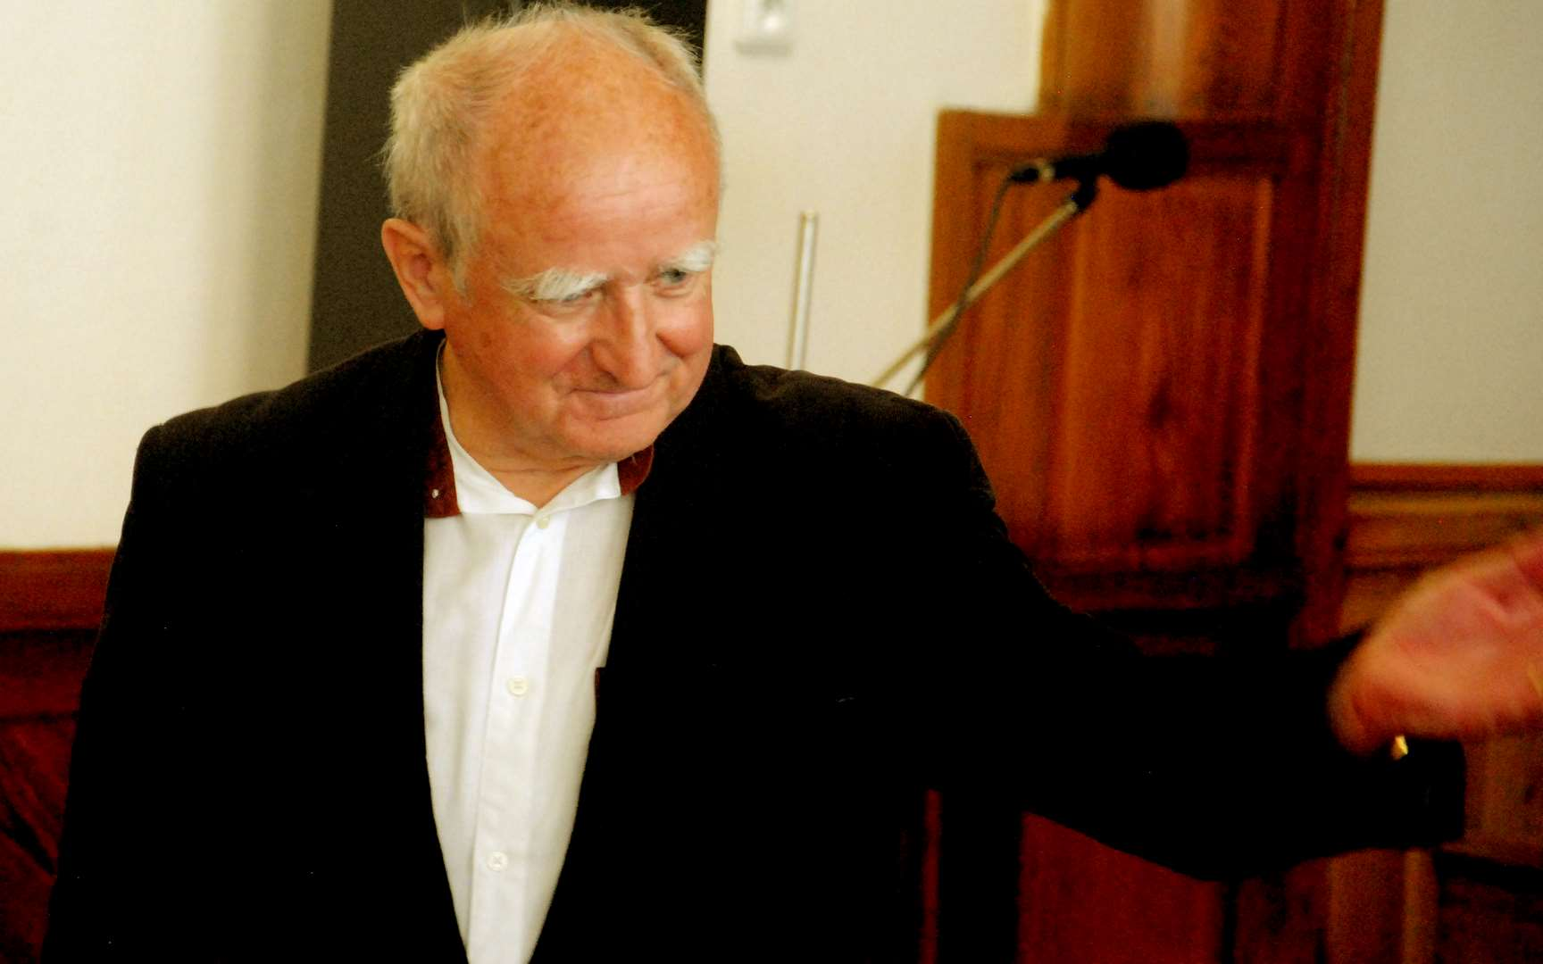

Concert of the Trio EUTERPE - Vojtěch Mojžíš - Gallery of Visual Arts in Hodonín

The third concert of Forfest 2024 took place on Tuesday, June 18, in the baroque, centrally arranged Church of St. John the Baptist in Kroměříž. Violist Petr Vaculovič performed his composition Stabat Mater there. It is a boldly conceived work that tries to express the economical means of expression of a single string instrument and, over the entire afternoon concert program, to interpret the course of a serious, dramatic and emotionally extremely deep event of the New Testament story using purely musical means. The composer and at the same time the performer fully utilized the acoustic advantages of the sacral space, which rarely resonates not only with the theme of the composition, but also with the color of the solo viola, especially with its deepest positions. The concert left a deep impression.

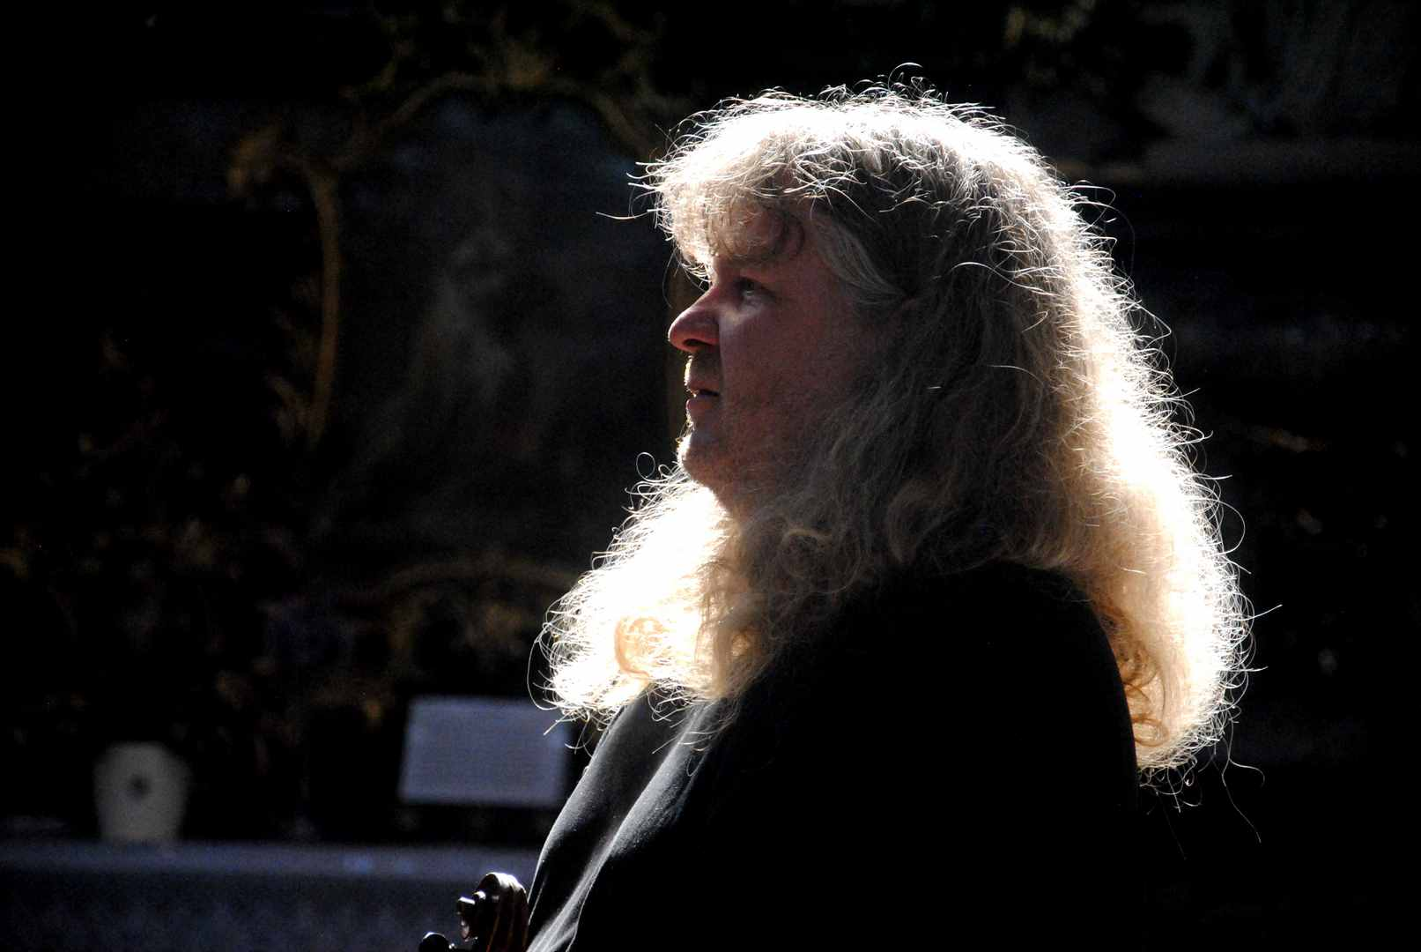

Petr Vaculovič - Stabat Mater FORFEST 2024

The Saturday evening concert on June 22 belonged to flutist Lenka Kozderková. She performed her solo recital in the inspiring environment of the Museum of Kroměříž, in its art exhibition dedicated to the work of Max Švabinský. She enthusiastically performed four contemporary compositions of the same genre, "live electronics", where the listener in the auditorium is exposed to a musical creation composed of a live interpretative performance, in this case a flute performance, and a pre-prepared electro-acoustic track.

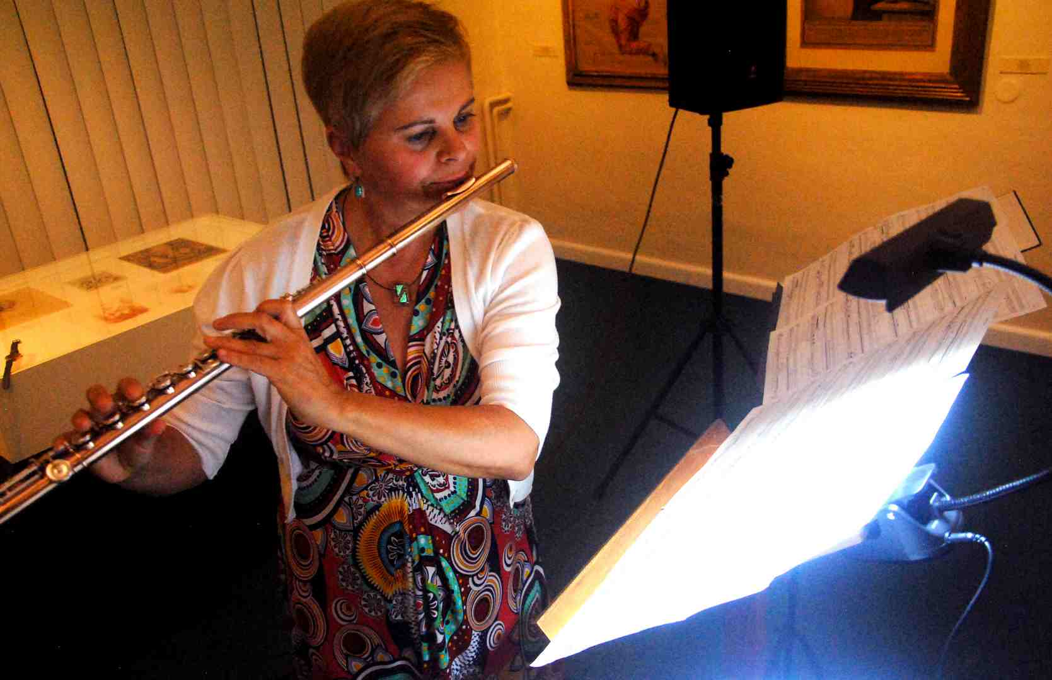

Lenka Kozderková CZ

First, a composition called Podoby noci by the recently deceased Prague composer Hanuš Bartoně was performed. It is his last work, we heard it in a world premiere. It was followed by Survivor by composer Petra Šuško. Jaroslav Šťastný is the author of the composition Goelan for flute and belt. The concert closed with Paradise lost (**Ztracený ráj**) by Miroslav Pudlák. Both of the latter two compositions also had their world premiere at Forfest this year.

Kozderková is an instrumentalist who is clearly fascinated by contemporary experimental work. She copes with various forms of flute interplay with the soundtrack with extraordinary enthusiasm, as perceived by the four authors of her performance. Bartoň carefully wrote out both voices in the score, so that the performer only had to carefully follow the parallel voice in the score for perfect interplay. In Petra Šuško's composition, the performer had to use a stopwatch for coordination. With Jaroslav Šťastný, who calculates with relatively great improvisational freedom and only indicates his intentions in the score in a framework, with poetic verbal commentary, it was not necessary to pay so much attention to the absolute accuracy of the interplay of the two components. On the contrary, with Pudlák, the flutist had to follow the set second structure very carefully. This author limited himself in his composition to a traditional, albeit virtuosically conceived instrumental setting, thereby distinguishing himself from the other three colleagues, who abundantly expanded the expressive arsenal of the flute with innovative virtuosic elements, especially the entire range of sounds of a non-tonal nature.

-------------------------------------------------------------------------------

The accordion and violin duo is a seemingly disparate combination. While the violin boasts a rich history, spanning from the Baroque masters to the present day, the accordion is a newcomer to the cultivated traditional music scene. It is still developing structurally, but its enthusiasts among the performers are already creating the highest artistic values. It is therefore not surprising that contemporary composers are appearing who write for the instrument and that they are looking for and finding suitable chamber partnerships for it. One of the notable variants is the combination of the accordion and the violin.

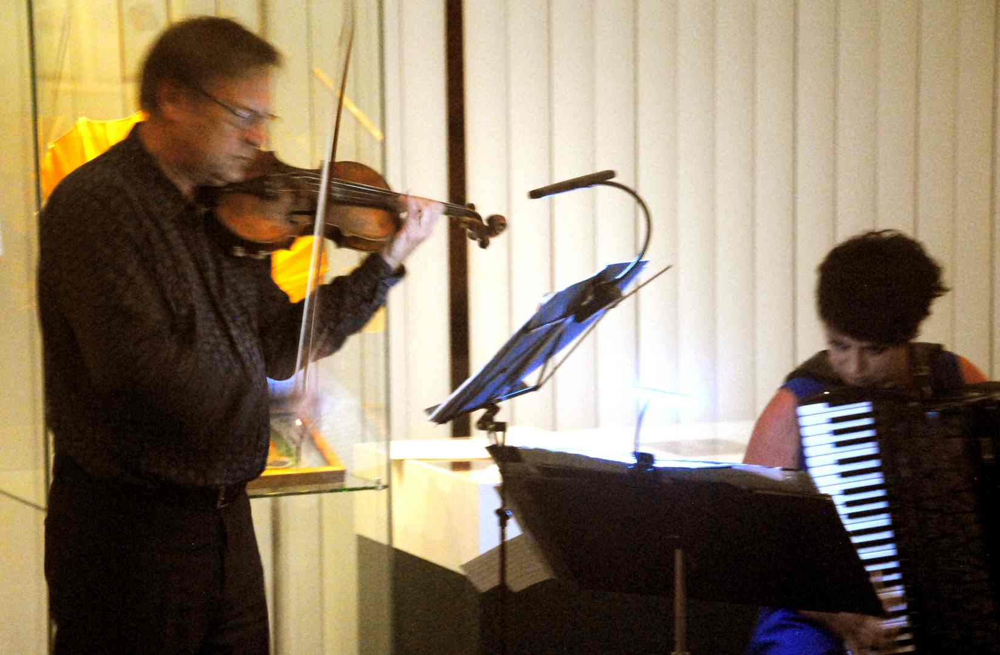

Miroslav Vilímec - Jarmila Vlachová CZ

The current 35th year of Forfest was visited by a duo consisting of Jarmila Vlachová – accordion and Miroslav Vilímec – violin. The performers prepared a rich program for the Kroměříž festival, composed exclusively of contemporary works from a relatively small region, West Bohemia. Their recital took place in the exhibition hall of the Kroměříž Museum on Sunday, June 23rd afternoon. The program included compositions by Jiří Bezděk, Jiří Teml, Miroslav Vilímec, Patrik Kotlár, Pavel Samiec and, at the very end, a composition by the Polish composer Grazyna Bacewiczová.

Jiří Bezděk and Jiří Teml wrote extensive compositions with serious content. Bezděk found inspiration for his three-part composition in the ancient Czech past, reaching for realities related to the reign of Přemysl Otakar 1. His three-part composition is called Sonata for Queen Dagmar for violin and accordion. Jiří Teml was not so specific in his inspiration, he called his two-movement composition Menuet and Dance for Violin and Accordion. The first interlude of the concert was the inclusion of his own solo violin composition by the great virtuoso Miroslav Vilímec, who, inspired by the violin work of Johann Sebastian Bach and Nicolo Paganini, created an unusually difficult fantasy called Bachaniniana for solo violin. The composition contains undisguised, but humbly chosen, reminiscences of well-known violin works by both greats of the musical past. No one other than a true master of the violin would be able to create and interpret such a thing, which Vilímec undoubtedly is. Patrik Kotlár's Sonata piccola is a three-movement composition with a classical arrangement, where the opening movement is dominated by a resolute and dignified expression, the second is predominantly a chordal arrangement, and the third has a dance-like giocca character. Accordionist Jarmila Vlachová also diversified the concert program with a solo piece for her instrument. She performed Sonata da chiesa by another Pilsen composer, Pavel Samiec. This author also chose a playful tone for his short piece, from a technical point of view he masterfully equalized both manuals of the instrument. Although he did not avoid using tonally indifferent effects, especially clusters, his expressive language can essentially be described as tonal.

Especially in the two opening pieces (Bezděk and Teml) the authors' effort to bring together and blend the specific expressive means of the violin and accordion is evident. This is evident, for example, in the area of ​​dynamic progression, where the accordion is unusually malleable in long values. Both authors often find the violin's counterbalance in a dense, dynamically elaborated tremolo. The performers were perfectly coordinated and mutually supportive throughout the whole concert, however, it must be stated that the accordion, with its significant sound potential and power of sound, i.e. dynamically, often prevailed over the violin too much...

---------------------------------------------------------

A somewhat unusual event at this year's Forfest was the recital of two Asian artists, the Chinese Xiao Dong Wei, playing the erhu, and the Japanese Yuki Mack, who accompanied her on the piano. The erhu is an oriental string instrument, also known as the Chinese violin. Above a small barrel-shaped resonant body resting on the player's knee, rises a long thin neck, on which two strings are anchored. The strings are shortened for the purpose of changing the intonation not by pressing the fingers on the neck, but only by a sensitive touch. The instrument has a specific, colorfully captivating, dense timbre, its tonal range reaches higher positions.

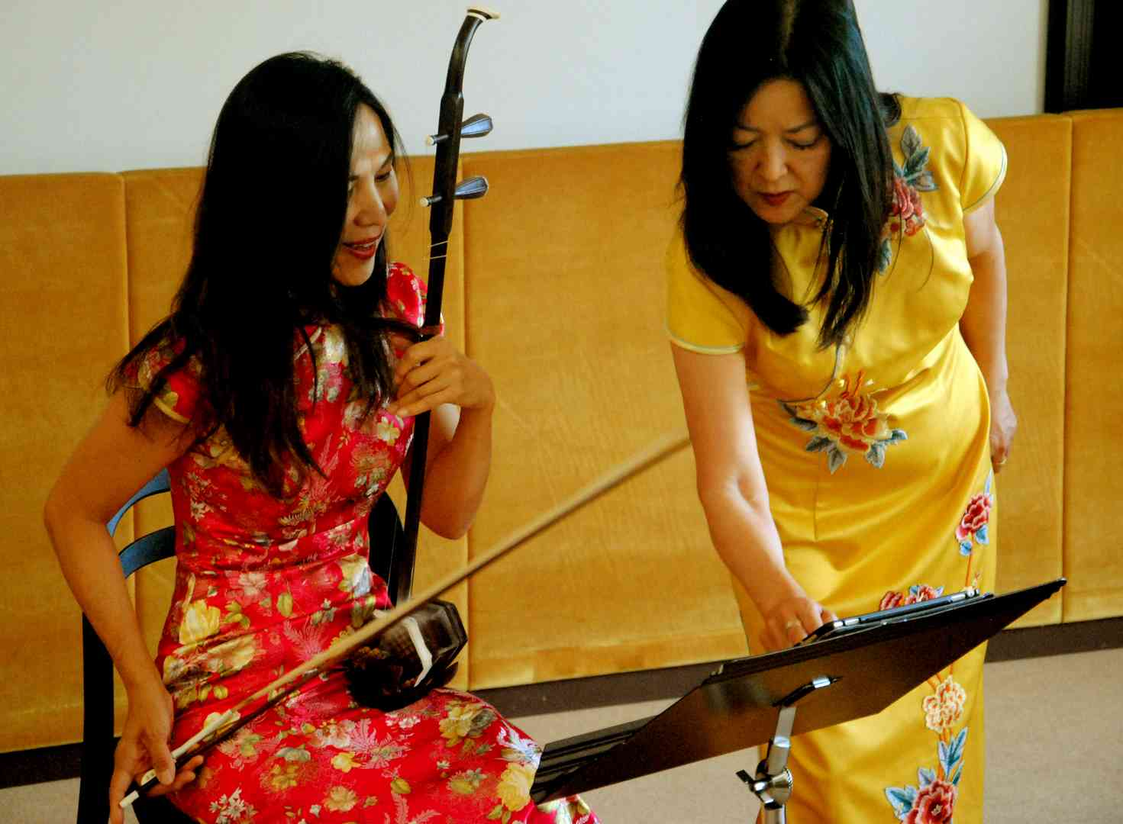

Xiao Dong Wei /China – USA/ - chinese violin, Yuki Mack - piano /Japan – USA/

The recital took place in the hall of the Museum of Kroměříž on Monday, June 24th in the afternoon. These artists were included in the Forfest program probably on the initiative of Massimiliano Messieri, a composer and conductor from San Marino, a long-time supporter and frequent guest of the Kroměříž festival. He always comes to Moravia with an original program built on the imaginative application of the latest musical trends, usually associated with the use of new means of realization (for example, a sound recording that is directly incorporated into a specific interpretative performance). Now, however, we had the opportunity to get to know him from a completely different side, as a creator seeking new possibilities of expression for himself in connection with ethnic music. He indicated the theoretical justifications for his new creative acts that morning in his theoretical contribution as part of the festival colloquium.

Xiao Dong Wei and Yuki Mack included two of Messieri's compositions in their concert performance - "Scents" - six caprices for erhu and piano and "Kojo no Tsuki Variations" - variations on a Japanese song. Based on Messieri's lecture at this year's colloquium, we will better understand his creative methods used here. The concert also featured authentic, yet stylized oriental music for erhu accompanied by piano. The piano parts of all these compositions are written decently, in a European style. Pianist Yuki Mack approached their implementation with a measured distance. In this block, we heard Candle Dance by Tianhua Liu, Ripening of grapes by Wei Zhou, San Men Gorge Caprice by Wenjin Lu, Poem of Spring by Yiliang Zhong, Birds in the Hollow Mountain by Tianhua Liu, Butterfly lovers by Zhanhao He, Gang Chen and Sunshine on Taxkorgan, also by Gang Chen.

------------------------------------------------------------

Just four days after the summer solstice, on Monday evening, July 24, a concert by the Brno ensemble Ensemble VERSUS, a chamber ensemble of students from the Faculty of Arts of Masaryk University in Brno, took place as part of Forfest at the St. Moritz Church. The program was called Pentecost in Contemporary Music.

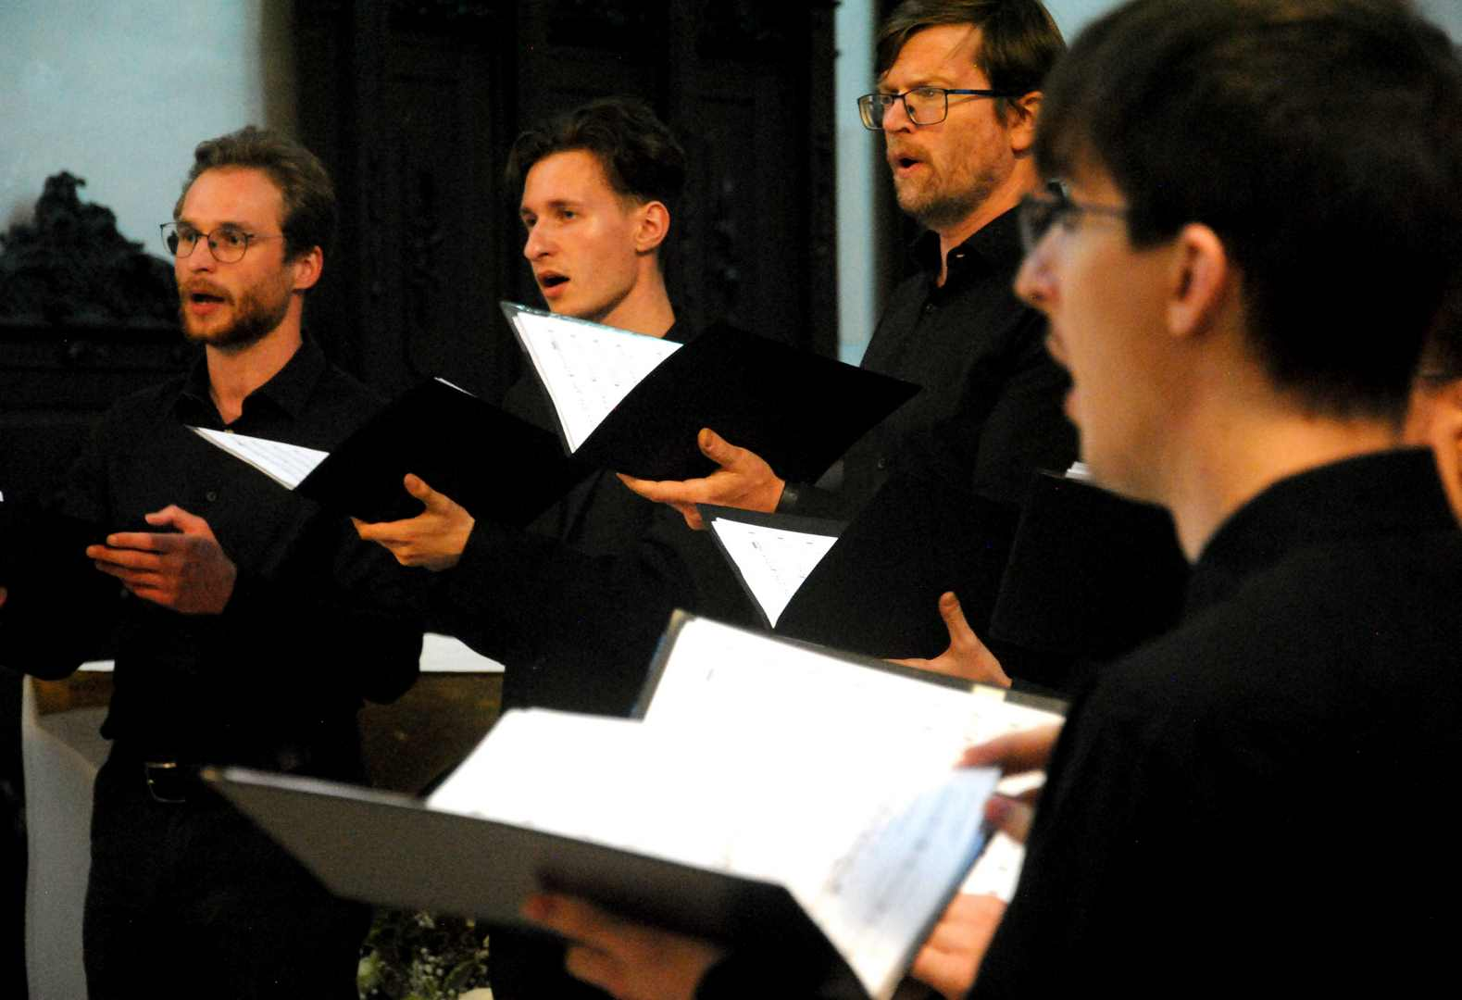

Ensemble Versus 2024

At the beginning of the concert performance, organ improvisational entries by František Fiala were heard.

The sixteen-member chamber choir, conducted by Patrik Buchta, stood in front of the altar in the church nave during the concert. It performed four a cappella compositions by two male and two female composers - Framtišek Fiala: Venite exultemus Domino, Tereza Opálková: Spiritus Domini, Markéta Brothánková: Veni Sancte Spiritus, Ondřej Kukal: Veni, Creator Spiritus.

The musical language of all four compositions shows a relatively large number of similar features. They often feature second and fifth consonances, their cluster surfaces have a diatonic basis, which in low dynamic positions and slow tempos brings a subtle expression of calm and collectedness. They do not avoid the choral type of melody, the alternating use of homophony and polyphonic structures, and benefit from the almost intoxicating reverberation of choral singing in church spaces.

At the very end of the program, the choir performed Fialo's festive Te Deum Laudamus for mixed choir and organ. The audience particularly appreciated the expressive adequacy of all compositions, the knowledge of choral setting and the creative professionalism, the interested and yet confident approach of all performers.

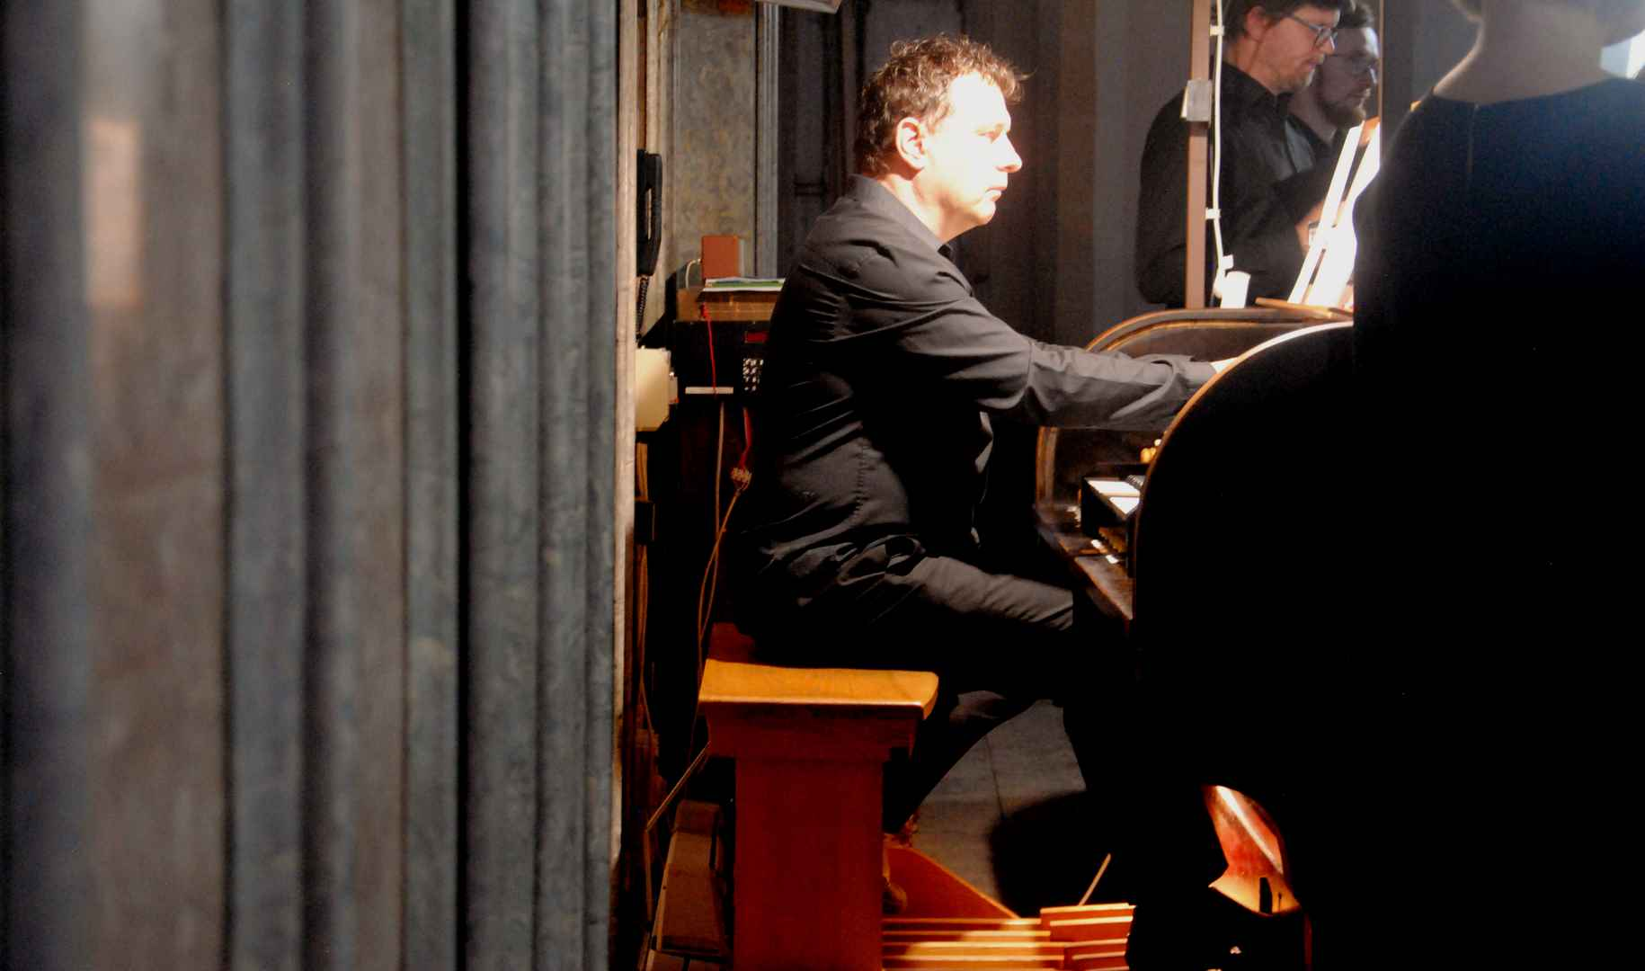

Ensemble Versus 2024 - František Fiala - organ

Czech accordionist Julie Hirzbergerová, who lives in Germany, performed on Tuesday, June 25th, in the afternoon at the exhibition Hall of the Kroměříž Museum. She prepared a program consisting mainly of extremely demanding contemporary compositions, emphasizing non-traditional accordion interpretation techniques.

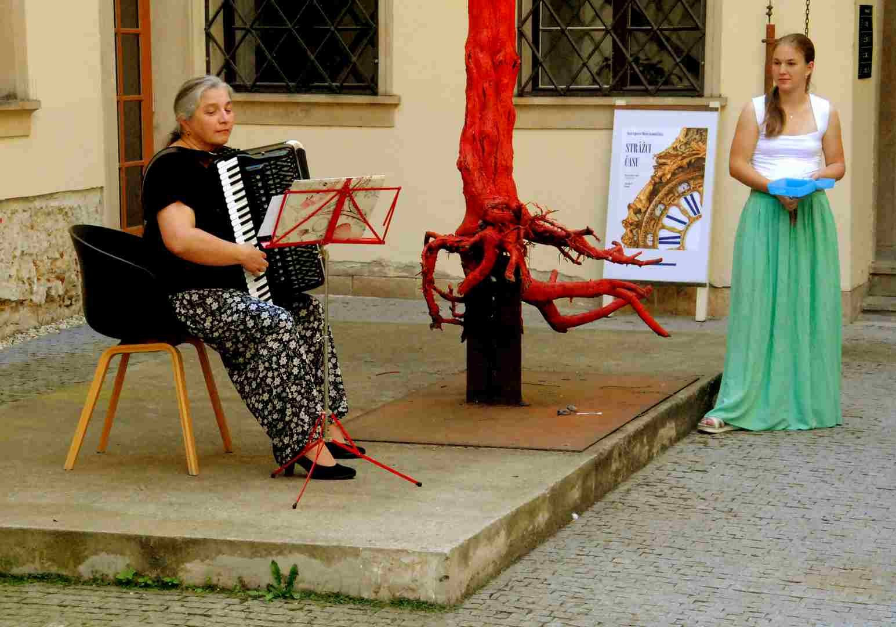

Julie Hirzbergerová - Anna Hirzbergerová /Germany - CZ/ - Court of Museum

We listened to Breathless by Israeli composer Netto Aloni, Melodii by Japanese Toshio Hosokawa, Tak riekol Isaiah by Russian-Ukrainian composer living in Slovakia Yevgeniy Irshay. The highlight of Julie Hirzbergerová's performance was the performance of the composition De profundis by Tatar composer Sofie Gubaidulina. The performer mastered the demands of this expressive work with ease thanks to her tenacious approach and emphasis on non-musical content, which is based on spiritual themes. Two compositions can be considered a certain counterpoint to this type of expressive tension, the opening lyrical cycle Gedicht von Trude Köchert by Herrmann Markus Pressl and the Christmas meditative Alleluja, Vidimus Stellam by Finnish composer Tomi Juhanni Kellönen. Both are written for violin and accordion. Julie Hirzberger entrusted the violin part and the recitation of the relevant literary part to her daughter Anna Hirzberger, who added youthful fragility to the overall tone of the concert.

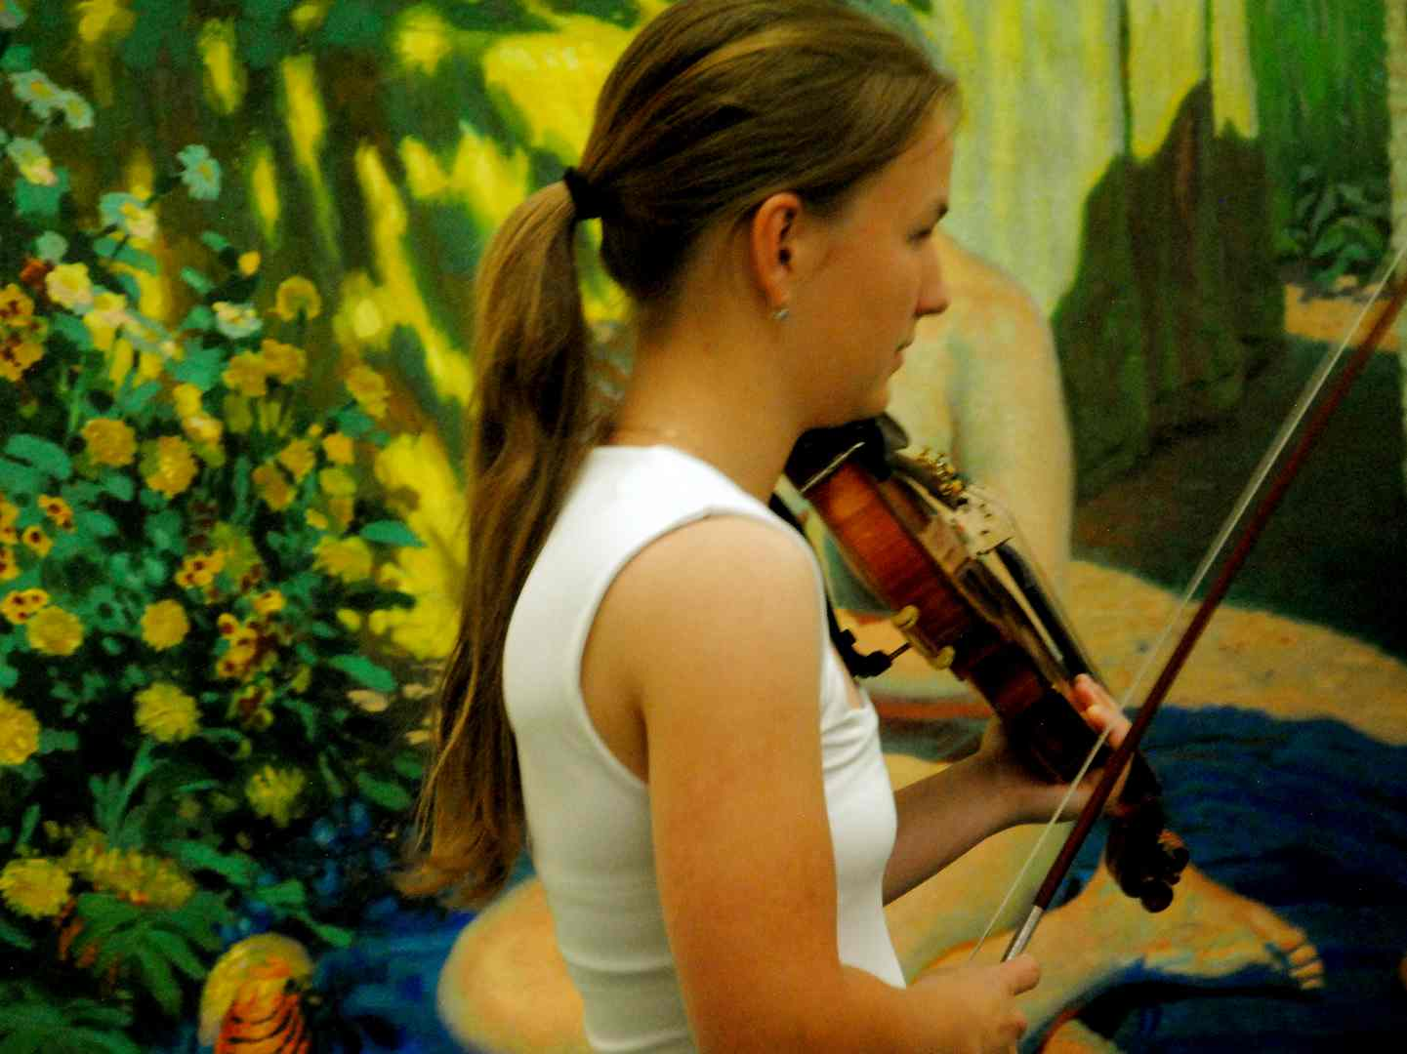

Anna Hirzbergerová /Germany-CZ/ - Museum gallery

------------------------------------------------------------------------------------

That evening, Wednesday, June 26, 2024, nature showed Kroměříž its dark side. After a day of heavy, stuffy air, which the entire Forfest participants spent in the Kroměříž Museum watching the final papers of the colloquium, the moment came when heavy storm clouds descended on the city and its wide surroundings. Lightning flashed from them, a strong wind rose and it began to rain heavily. However, this had almost no effect on the climate inside the Church of St. Moritz. Perhaps only such that entering the sanctuary, under its Gothic vaults, gave the impression of even deeper intimacy, timelessness and peace than ever before.

An international duo performed here – Japanese soprano Nao Higano and Czech organist Petr Kolař. Their program alternated between solo organ entries and vocal, supported organ accompaniment. There were four pieces for solo organ in total. At the beginning, we listened to the Choral Fantasy by the young, only twenty-year-old Leoš Janáček. It is masterfully written in the intentions of its time and genre, so it is possible to trace the melodic and harmonic thinking of the mid-19th century and the expression of the composer's deep piety. The Fantasy for Organ by Toshi Ichiyanagi, which is about one hundred and twenty years younger, is written in a completely different, contemporary language. Here we encounter glissandos, clusters, and toccata-like passages, but everything is set in a fixed order. Jan Šimíček also wrote his organ Intermezzo only recently, in 2023. It contains resonant organ plenaries, trembling dense, urgent figurative surfaces, formed by delicate dissonant consonances in a colorful register. Victimea paschali laudes by Brno composer Vladimír Werner is a composition that continues the grandeur of Johann Sebastian Bach's organ work. All these organ pieces are united by delicate lyricism and sublime calm. Nao Higano entered this context with her round, slightly vibrato voice of rich timbre. Accompanied by the organ, she performed Jaromír Hnilička's strophic composition Ave Maria for soprano and organ. The work was created in 2010, is melodically simple, the vocal part winds over the decent accompaniment. On the other hand, the vocal part of the composition Claudio, Nao, Leo for voice and organ by Miloš Štědroň places unusually high demands on intonation and vocal technique. Both parts develop relatively independently, i.e. as two parallel worlds. The work is composed of separate episodes, each with a different character, usually ending with a consonantly formulated punchline. The composition was performed at the Forfest in its world premiere. L´ombre qui viendra for soprano and organ by Juraj Beneš could be described as a specific type of vocal fantasy. This composition was also performed here for the first time. It places high demands on the performance of the vocal part. Nao Higano mastered it safely, with balanced calm and enthusiasm. She was not troubled by frequent unsingable intervals. Her soft, delicate and colorful soprano was able to develop in full beauty.

The organ is only minimally featured in the piece, rather than providing accompaniment, creating some sort of dialogic interludes. The evening closed with Olivier Messiaen's short piece Vocalise for voice and organ. It seemed like a gentle, mostly melismatic narration by the vocalist, floating above the quiet surfaces of the organ.

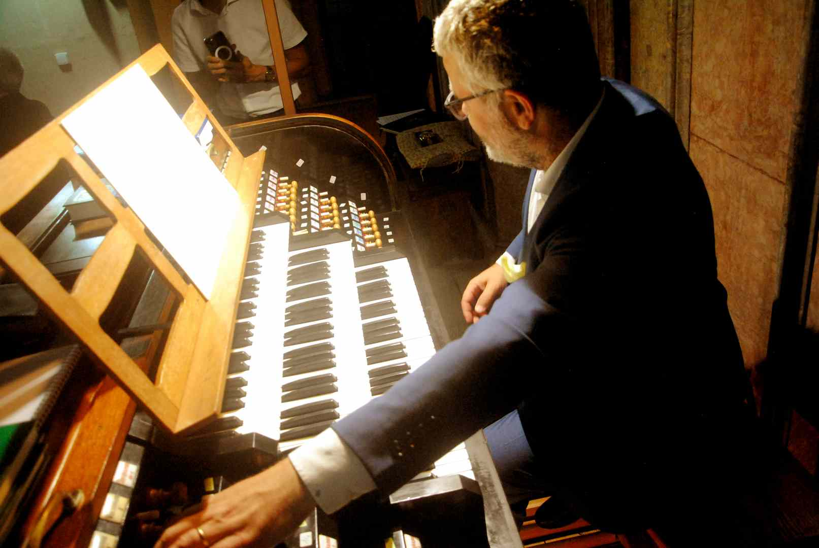

Petr Kolař - CZ 2024

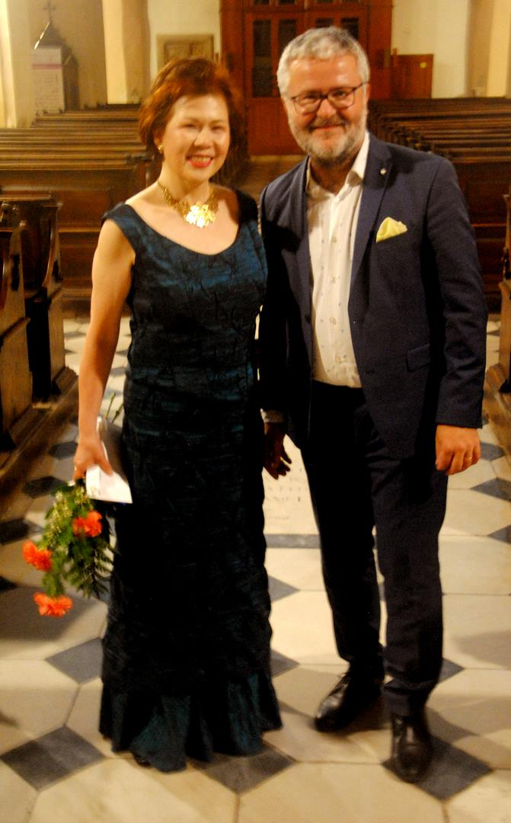

Nao Higano /Japan/, Petr Kolař /CZ/

------------------------------------------------

On Thursday, June 27th, in the afternoon, a chamber concert was held at the Museum of Kroměříž, featuring a trio of local artists: Martina Macko – soprano, Aneta Kořínková – flute and Martina Mergentálová – piano. Their program consisted mainly of contemporary Czech music. The soprano accompanied the entire concert with a verbal commentary.

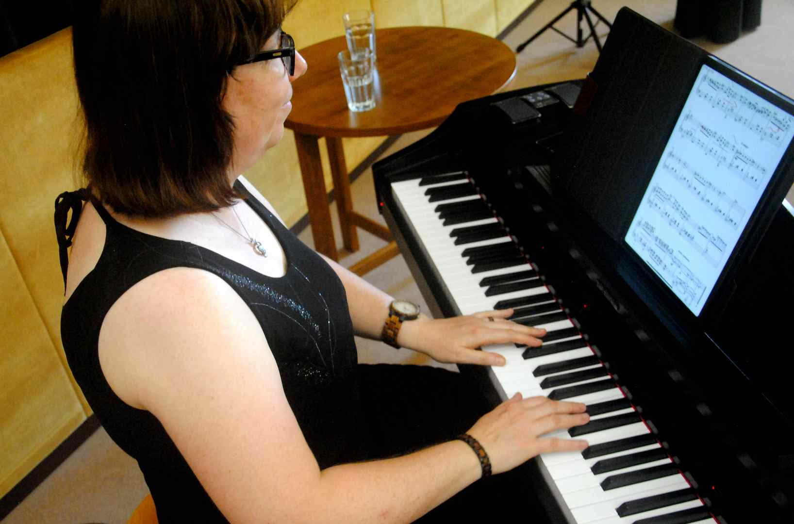

Martina Mergentálová /CZ/

First, we listened to Songs with Flute by Ilja Hurník, which is a three-part cycle of friendly, joyful music. The flute complements the vocal line with small glosses that spans the piano accompaniment. Pavel Haas wrote Six Songs in Folk Tone for Soprano and Piano to the words of folk poetry. The vocal part is characterized by simplicity, while the piano part is unusually demanding from a technical point of view. The following Two Waltzes for Piano by Luboš Sluka is reveling in witty stylization. Here, the author has significantly approached a lighter genre. Jan Novák is the author of the extensive composition Sonata Hoson zes for flute and piano. In terms of expressive means, the author has approached the language of his teacher, Bohuslav Martinů. We could see how close the two authors are to each other by comparing the next number on the program, which was Martinů's Two Songs. Five Hebrew songs were written by the composer Eric Whitacre. From this cycle, we heard the song Temuná. The program ended with the song La betulla from the Aikio Songs series, written by Paolo Ugoletti. All three performers played the music naturally and with ease.

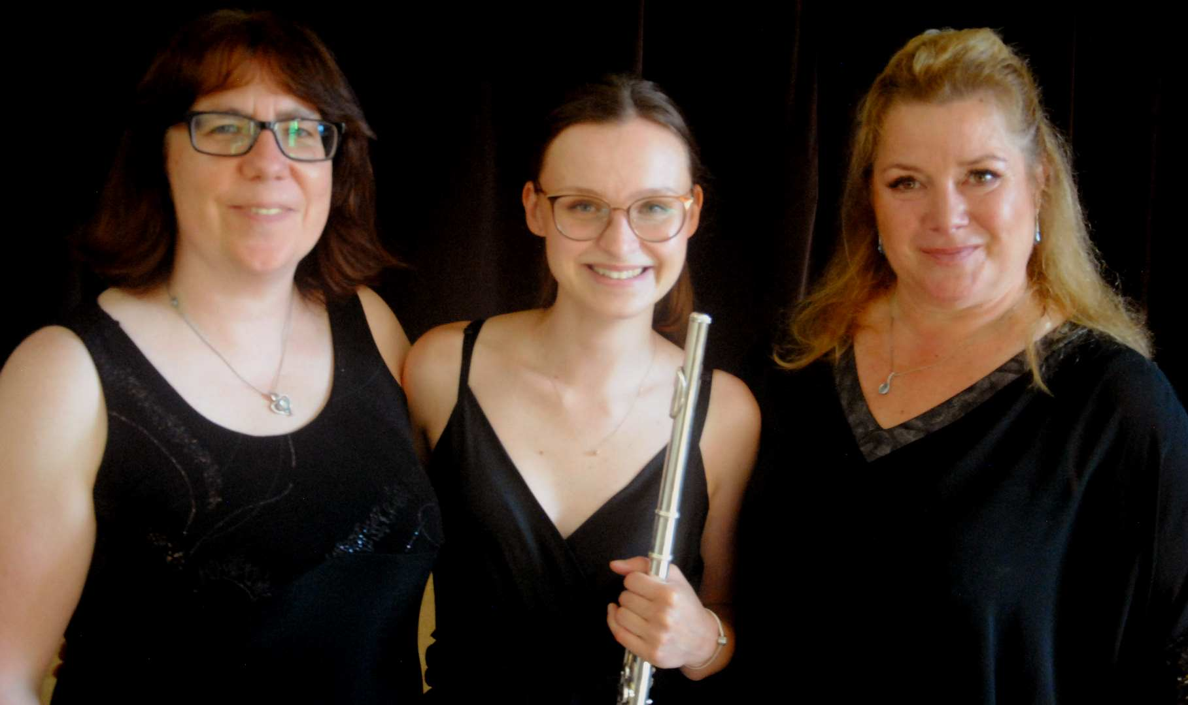

Martina Mergentálová - Aneta Kořínková - Martina Macko CZ

-----------------------------------------------------------------------

Friday afternoon on June 28th in the Kroměříž Museum belonged to the chamber ensemble Trio Aperto. Essentially, it is a wind quintet without flute and French horn. It consists of oboist Barbora Šteflová, clarinetist Jan Charfeitag and bassoonist Pavel Horák. It was founded in Olomouc, but is very close to the Brno music scene. The members of the trio play soulfully, with ease of tone.

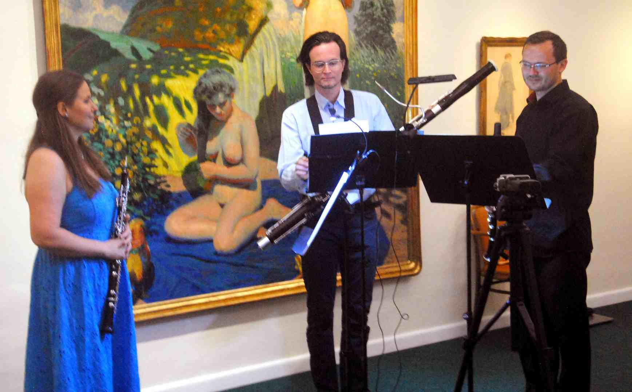

Trio APERTO 2024 - Picture Gallery - Max Švabinský Memorial in the Museum of Kroměříž

The opening performance included Psalm 150, a composition by Markéta Brothánková. It uses unconventional methods of instrumental articulation, and right at the beginning, the human voice is heard - the oboist pronounces the sentence "Everything that has breath, let it praise the Lord". Not only human breath, but also breathing through the instruments is incorporated into this mysterious composition. It has a gradational course, dominated by long held tones in deep positions. The author was personally present at the successful performance of this composition of hers. Microworlds No. 10, Op. 24 was composed for Trio Aperto by Radim Bednařík. He was also present at the performance of his composition at Forfest. He wrote a cycle of shorter, mostly slow movements, in which second consonances and vocal mixtures are prominent. There are no aleatory areas, but we also hear a felt diatonic melody. For this reason in particular, the composition sounds lyrical as a whole, sometimes even melancholic. Kateřina Szymeczková's Trialogue metaphorically hides a discussion, an excited conversation and a kind of latent story. The author wrote it in an unusual type of raster notation, which offers the performers considerable freedom of expression. The players swapped their instruments for sticks for a certain period of time, thus replacing long tones and rubato melodies with percussive elements. The composition Urban son was written by the young Mexican composer Omar Rojas, a student at the Brno JAMU. He incorporated an electroacoustic component into it. We hear snippets of authentic Mexican music from the speakers as a counterbalance to the trio of real instrumental parts. However, the predefined sound component here often outweighs the live music in its scope. Finally, Music for Three by Jiří Matys, one of the representatives of the strong generation of Brno composers of the second half of the 20th century, was performed. It is an exemplary example of the author's creative style, as he refers to his chamber compositions with the word "music". By this he means the type of creativity in which spontaneity and playful musicality dominate.

A concert by violist Pavel Březík and his son, organist Pravoslav Březík, was composed exclusively of Czech works. It took place in the church of St. Moritz on the evening of Friday, June 28. The opening performance was Cantabile for viola and harpsichord by Zdeněk Lukáš. Both instruments, the viola and the harpsichord (here replaced by an electro-acoustic instrument), sounded from the choir, so their sound had sufficient strength and penetration, carrying colorfully throughout the whole church. Lukáš is characterized by diatonic thinking and natural singing. This is especially the viola part of his composition. However, there were also contrasting, lively chromatic passages. These found application especially in the harpsichord. The extensive Five Morning Prayers for viola solo by Ivan Kurz also sounded from the choir. This music can be characterized as introverted and meditative. Although the composer limited himself to only one instrument, he wrote a work of profound intellectual importance. The Christmas toccata for organ by Otmar Mácha, performed by Pravoslav Březík, sounded monumental. It begins in a gentle, quiet register, and only gradually does the composition develop into an elemental toccata. However, the conclusion brought clarity. Concentration of thought and urgency are characteristic features of Klement Slavický's entire work. He also applied this approach in a relatively extensive composition, which he called Rhapsodie for viola solo. Jan Jirásek, a composer a whole generation younger, embodied his composition invention in shorter dimensions. He gave his composition Symbiosis for organ a distinctive sound; when choosing a texture, he also did not avoid toccata runs, which he used as a counterpoint to the inconspicuous opening section. The following composition, Labyrint for viola solo, was written by Kryštof Mařatka. He is also concise in his expressions, but even such a space was enough for him to express very contrasting worlds. He purposefully uses all the strings of the instrument, not just the deepest, intoxicatingly carrying "c". Jan Novák's Sonata chiesa for viola and organ is an extensive cyclical, four-movement work with an almost symphonic thrust. In the hints, Moravian modulation can also be heard in the dense interweaving. However, the shadow of sadness, so close to the character of the viola, in the last movement is graduated to clear, purely tonal positions. The final piece of the evening was Motto ostinato from the Sunday Music for Organ cycle by Petr Eben. With its dense toccata flow in the plenum, it rounded off this tastefully composed, intellectually focused program.

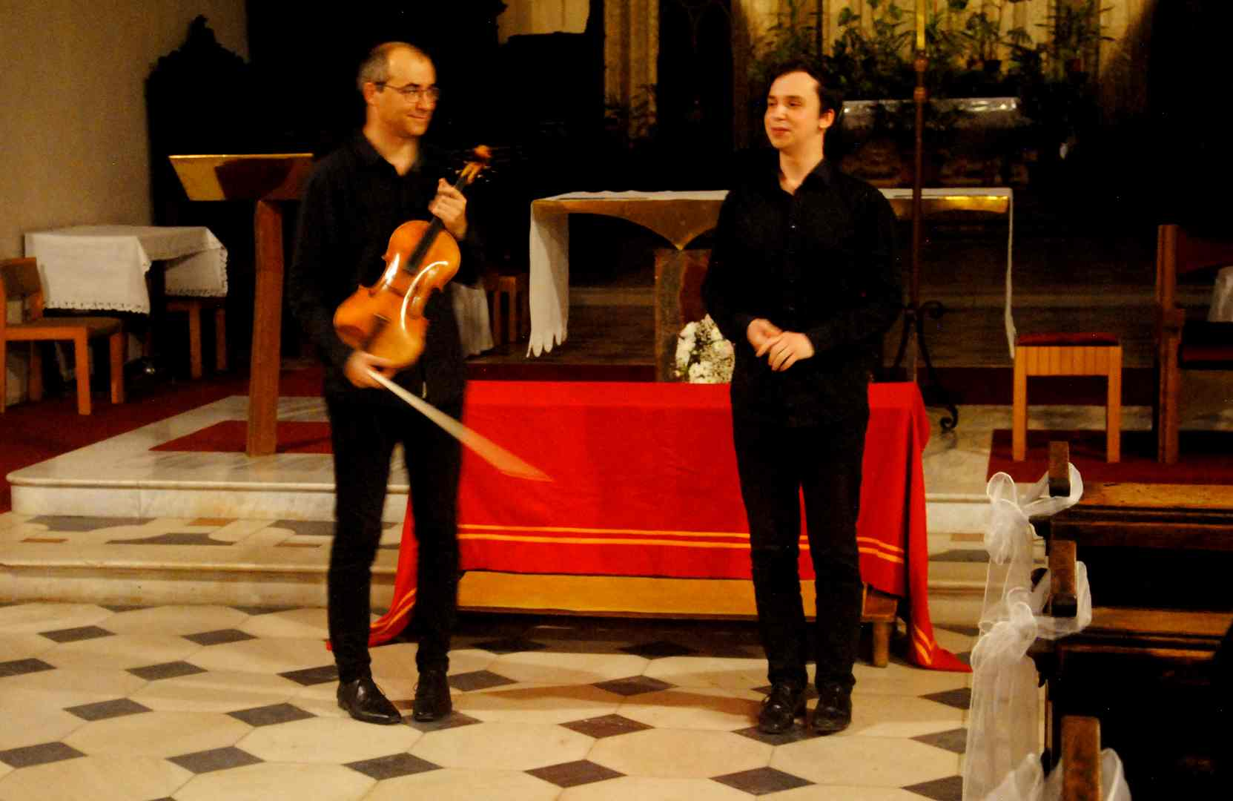

Pravoslav and Pavel Březík /CZ/

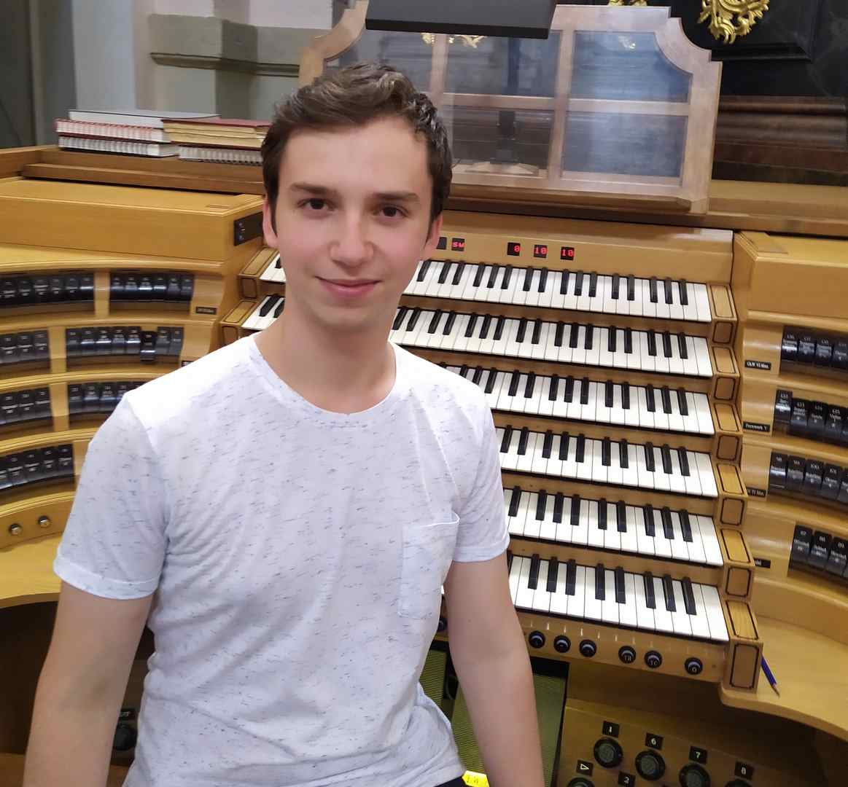

Pavel Březík /CZ/

----------------------------------------------------------------------

Chamber ensembles made up of pairs of instruments are a common occurrence at this year's Forfest. We have already heard the duo accordion violin, erhu and piano, singing and organ, viola and organ, and we are still waiting for the duo flute and guitar. Saturday afternoon, June 29, belonged to the duo violin and guitar in the conference hall of the Kroměříž Museum. Pavel Popelka played the violin, Lukáš Herůdek played the guitar. Both are still young performers, born in 2000, i.e. in the last year of the 20th century, both started conservatory studies only after graduating from secondary technical school, they are preparing for their artistic careers very conscientiously, they have big artistic plans for the future. They understand their artistic partnership completely equally, this is already evident from the program lineup that they offered to the dramaturgy of Forfest.

They introduced themselves with the extensive composition Sonata serenata by Jan Novák. Let us recall that another composition by this author was included in their program only a day earlier in the Church of St. Moritz by the viola and organ duo of Pavel and Pravoslav Březík. They also included the composition Prague Kaleidoscope by the Russian-Jewish composer Jan Freidlin. The author drew inspiration from our capital city. We had also had the opportunity to hear the work of Jiří Matys, a day earlier, at another concert. It was performed by the Trio Aperto ensemble. Now we heard Matys' Suite for solo violin. All the following compositions by the Cinderella - Herůdek duo were marked primarily by virtuoso guitar creations. The author of the three compositions for solo guitar with the collective title Fandango is the famous Joaquin Rodrigo. The five-part cycle of short characteristic movements by Manuel de Falla was called Siete canciones populares espanolas. This was followed by a work for solo guitar by Ástor Piazzolla, entitled Historie tango. We heard one more piece by this author at the concert, it was the final concert encore. However, the declared final piece of the concert was Béla Bartók's Romanian Dances. We heard it in a successful arrangement for violin and guitar, written by Lukáš Herůdek.

----------------------------------------------------------

VientoMarero duo, flute + guitar is an ensemble of Czech artists, flutist Michaela Meca and her husband, guitarist Jiří Meca. This ensemble is no newcomer to concert stages, they have already gained enough valuable experience. By a fortunate coincidence, this performance is the ensemble's 200th concert. They came to the Kroměříž Forfest with a rich, in many ways revealing repertoire. They performed it on the afternoon of June 30 at the Kroměříž Museum.

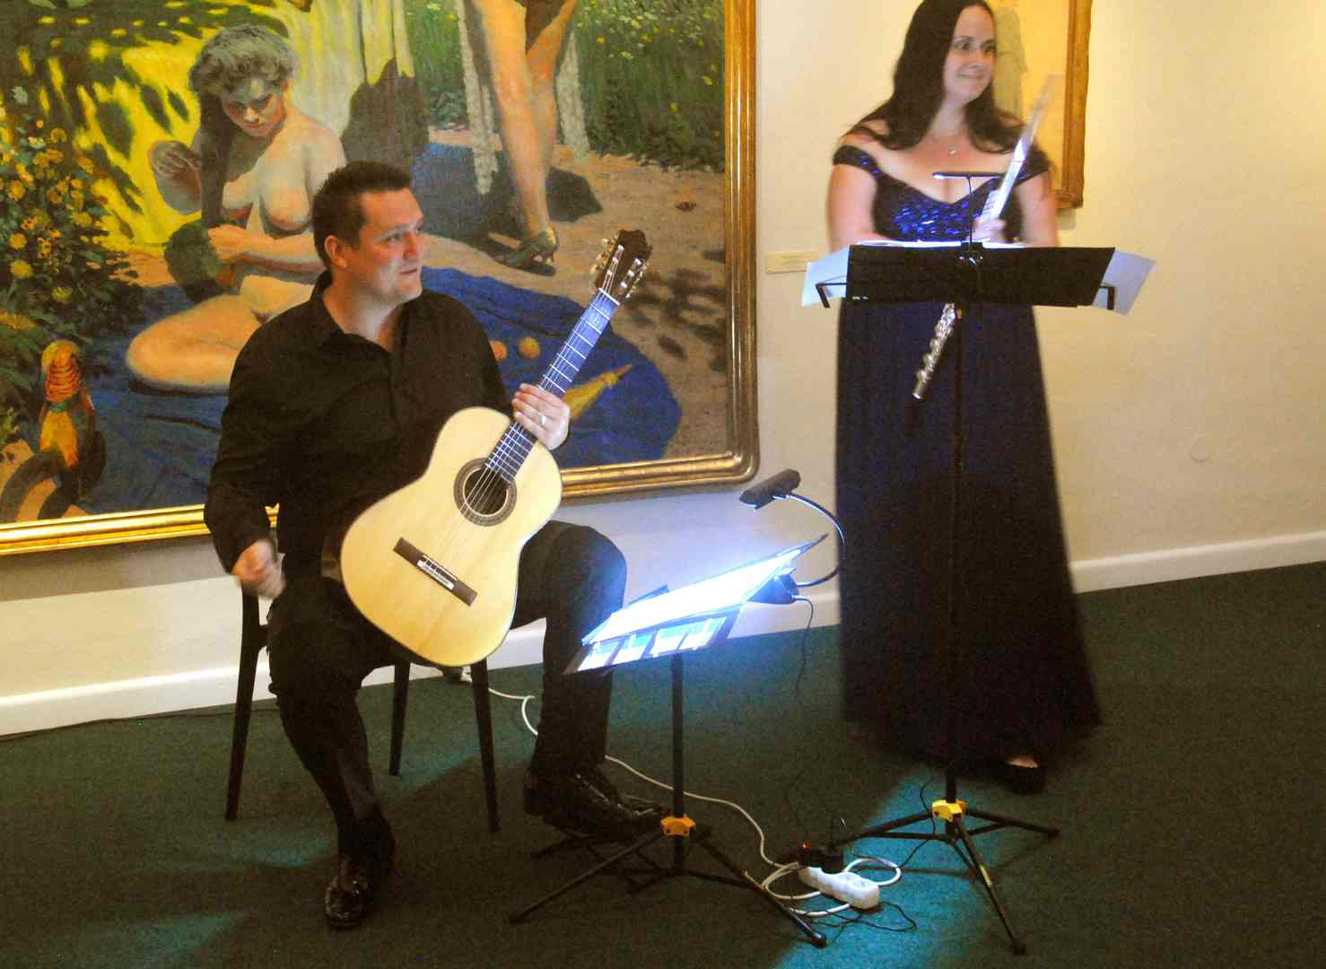

Michaela and Jiří Meca /CZ/

The Czech composition in the program is Pohlazení. It was written by the Czech composer Eduard Schiffauer. And the caress can really be heard throughout the piece. It is a slow, thoughtful dialogue, ending with a conciliatory gesture, contained in the final consonant chord. Another Czech composer is Franczisek Humel, his composition is called Espuna marina. From Slovak works, we heard compositions inspired by nature. The world premiere was of the composition …and the water was clear again by Peter Machajdík, the same provenance can also be attributed to the Russian composer and pianist Yevgeny Iršai, who works in Slovakia. Two of his compositions Luna e barca, vento e mare and Morning Rainbow were performed during the concert. The wider international music scene in the program of the duo VientoMarero is represented by two composers, the Greek Michalis Andronikou with two compositions – Flow and Journey to Harmony, and the Frenchman Alexandre Glizé with the three-movement cycle Vientos.

Jiři Meca is a guitarist with very good technical skills. He plays precisely, evenly, and masterfully handles all the specific pitfalls of guitar playing, especially flageolets, graduated vibrato, and various dynamic levels. He is therefore a solid support for the flute parts of his artistic and life partner Michaela Meca. She is well versed in non-traditional ways of flute articulation, playing in full tone, with feeling and grace. Both of them interpret both extensive, cyclical compositions (Sonata No. 1 in E by Luboš Bernáth, Vientos by Alexandra Glizé) and somewhat shorter ones (Michalise Andronikou, Franczisek Humel).

----------------------------------------------

Michal Novenko is a professor at the Prague Conservatory, systematically devoted to traditional composition techniques and organ playing. The program of this year's Forfest includes two of his organ concerts. The first took place on Sunday, June 30 at 8 p.m. at St. Moritz under extremely dramatic circumstances, even more dramatic than those that nature brought to the duo Higano and Kolař last Wednesday at the same place. The sky darkened in the afternoon and black clouds swept over Kroměříž, and a strong storm with torrential rain began. However, before the concert, the elements briefly calmed down, so that the audience could come to Moritz with almost dry feet. However, the elements did not completely cease, and ominous lightning made itself known through the Gothic church windows throughout the concert.

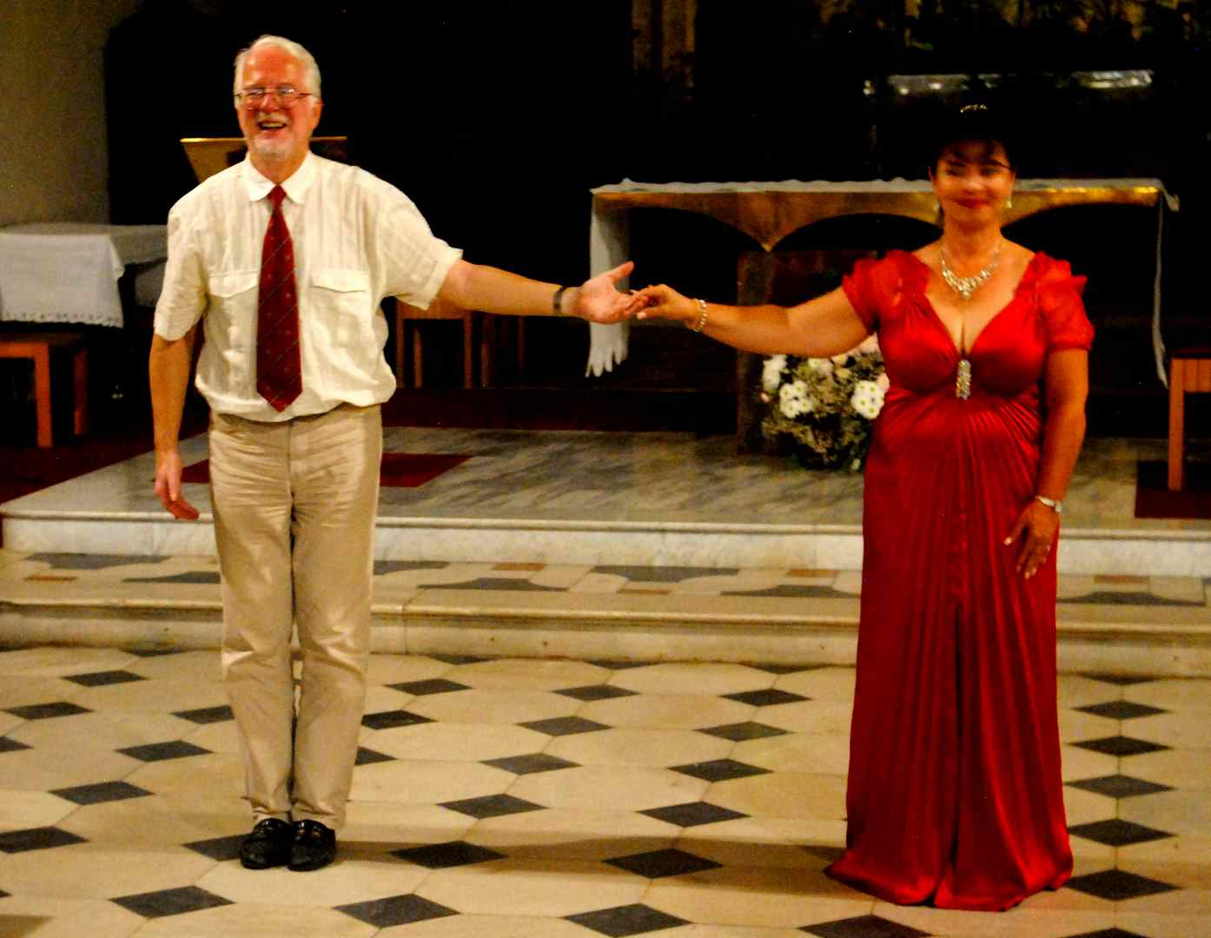

Michal Novenko /CZ/ - organ, Jana Koucká /CZ/ - soprano

Michal Novenko conceived both of his performances essentially autobiographically, i.e. as authorial recitals. He truly has a lot to offer. He began with Prelude for F. L. Věk. With this meditation, he recalled an ancient, beautiful spiritual song that had been adapted by composer Jiří Srnka before him, in a popular Czech television series from the period of the National Revival. The concert continued with Jitka Snížková's composition Medieval Reminiscence No. 2, a variation on the chorale of Saint Wenceslas. By including this title, Michal Novenko expressed his sympathy not only for the composer, but also for the given theme. The vocal part of the concert was performed by Jana Koucká. Her sonorous voice could be heard in Novenko's composition In honorem Sanctae Ludmilae. Another composition by the experienced author and performer, Sfogava con le stelle, a fantasy on motifs by C. Monteverdi, offered a rough sound and a quiet pianissima. Michal Novenko expressed his admiration for the work of Bohuslav Martinů by including three of his small pieces, Devotional Songs, Virgin Mary and Vigil. Virgin Mary comes from Martinů's Songs on One Page, sung again by Jana Koucká. She also made her mark in Novenko's song Ave Maria. The solo organ composition is Fantasia Mallorquiana, a kind of spiritual reminiscence. The premiere at the Forfest concert featured Novenko's Benedicamus Domino. The singer interpreted this exclamation while walking dignifiedly down the nave towards the altar. The conclusion of this concert, marked by dramatic natural circumstances, was a remembrance of Novenko's favorite teacher, Professor František Kovaříček. His Thanksgiving begins inconspicuously, in silence, and ends with a magnificent choral plenum.

Essentially the same program, but without vocal compositions, was performed by the organist a day later in the St. Wenceslas Cathedral in Olomouc at his second concert as part of this year's Forfest.

----------------------------------------------------------------

Our Young Orchestra is a project of students from the Bruno Maderna Conservatory in Cesena, Italy. It involves musicians from several countries, from San Marino, Russia, Japan and Italy. This orchestra first appeared in 2021 in the Basilica of San Domenico in Cesena with a baroque repertoire. This year, its members came to Kroměříž for Forfest exclusively with contemporary music.

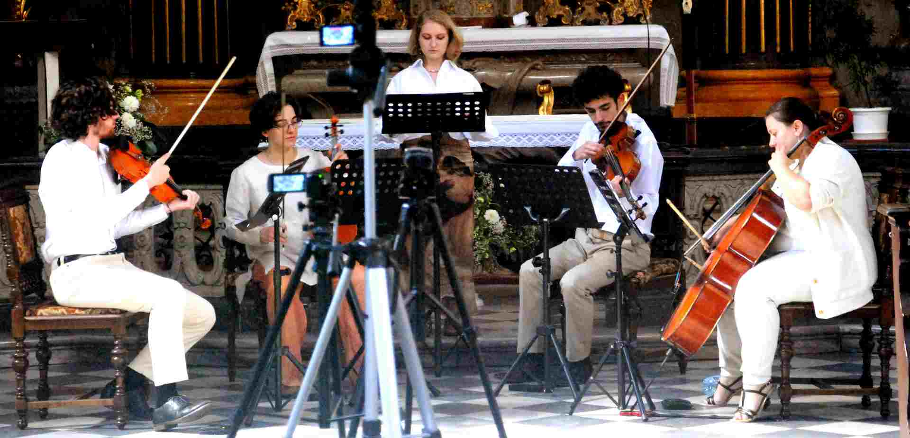

OYO Orchestra - / San Marino, Russia, Japan, Italy /

Their concert took place on Tuesday, July 2, 2024, in the baroque Church of St. John the Baptist and was organized in collaboration with the Maskfest International festival of San Marino. The members of OYO performed, all modestly dressed in white, as Anastasia Egorova – soprano, Constanza Dalmonte – trumpet, Umberto Frisoni and Viola Muzzi – violin, Antonio Giola – viola and Sofia Camazzini – cello. The program of their performance included seven compositions, the selected repertoire showing a rare unity of the compositional means used. John Luther Adams: "Dream of the canyon wrean" for string quartet, Stefano Benvenuti: "Meat Ticket" for female voice, trumpet and string trio, Antonio Gioia: "Chiaroscuro" for female voice and string quartet, Giulio Piras: "La forza della luce" for string quartet, Silvia Colasanti: "Alle piccole e grandi ombre" for human voice and cello, Massimiliano Messieri: "Liriche Sacre" eleven verses from the Old Testament for female voice and string quartet, Shai Cohen: "Circle of time" for trumpet and string quartet.

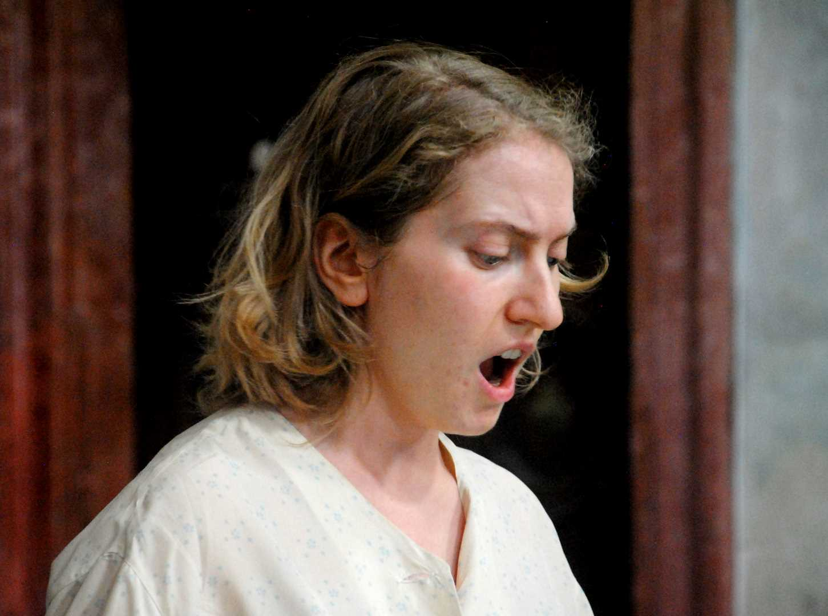

OYO Orchestra 2024 - Anastasia Egorova /Russia/ - soprano

It was obvious that the performers are very well trained in performing contemporary music, that they can handle it just as well as traditional musical styles. They played with passion, their performance radiated joy and self-satisfaction. Adams's String Quartet is a short piece, very economical in its choice of ideas. Through descending glissandos, the author creates an almost dreamlike mood. Benvenuti's composition combines and intertwines three different colorful elements - a string trio, a female voice and a trumpet. We hear long held notes and punctual entries here. The ensemble's violist, Antonio Gioia, is the author of the composition Chiaroscuro. In it, the female voice emerges inconspicuously, almost mysteriously, from the second consonances and pianissimo glissandos of the strings. Giulia Pirase's String Quartet in three parts brings a gentle, almost dreamlike mood. In the first, non-tonal sounds prevail (taps and other, especially noise elements), but gradually melodic elements begin to assert themselves in the interlude, which ultimately significantly prevail in the cycle and give the impression of Schubertian singability. The human voice in Silvia Colasanti's duo is not singing, but recitative. It was performed by the quartet's second player. The superior cello part is pensive and yet virtuoso, the structure of the work has a gradational course, the last word spoken is "morte". Massmiliano Messieri set the Old Testament theme to music in his vocal-instrumental composition. He too begins mysteriously with the second consonances of the string quartet in low dynamics and ends with an urgently clarified tonal harmony. The combination of the string quartet with the trumpet in the final piece of the concerto, in Cohen's "Circle of time", especially in the virtuoso passages, evokes the concertante principle. However, in the overall tone, especially due to the resonant potential of the church space of St. John the Baptist, the impression of dignity and grandeur prevails much more.

Thank you for this extraordinarily engaging and refined program. It was very unusual and engaging in the choice of compositional style and its means of expression.

--------------------------------------------------------------

The penultimate concert of Forfest 2024 took place on July 3rd at St. Moritz Church. Two prominent composers of Czech sacred music, Martin Flašar and Karel Hiner, participated in it.

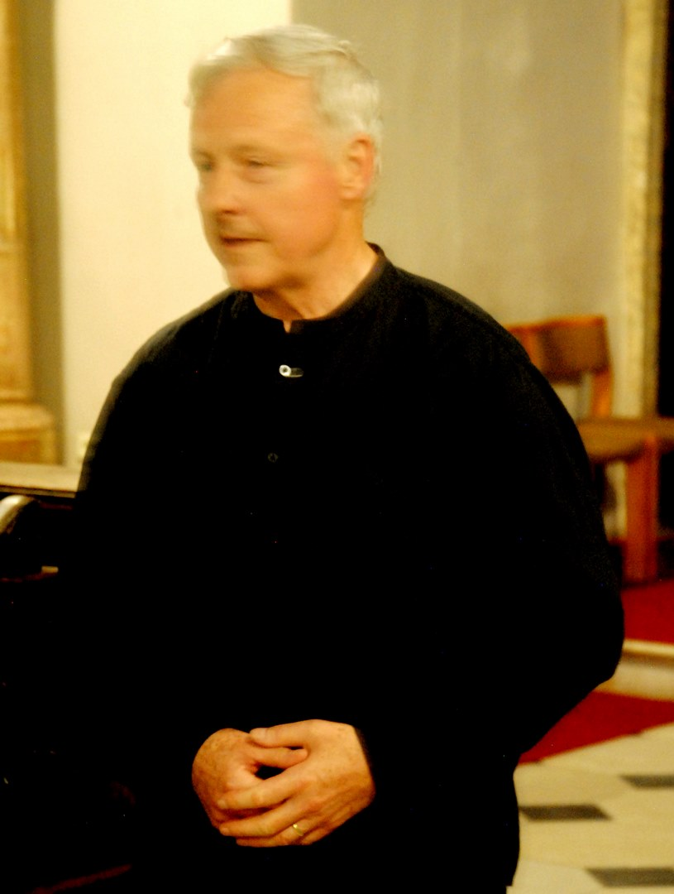

Karel Hiner – organ /CZ/

The opening part of the evening belonged to the Ensemble Serpens Cantat, consisting of the vocal duo Alice Ondrejková and Jan Ondrejka, organist Ilona Růčková and violinist Martin Flašar. We heard three of Flašar's compositions. First, Salve Regina for soprano and organ, followed by the composition White for organ. Flašar composed Te Deum laudamus for the entire ensemble. His music is not at all aggressive, it follows the musical thinking of the 19th century masters, but it is imbued with peace and deep piety. In the second part of the evening, the organ music of Karel Hiner was performed in an original interpretation. The program included his composition with the long title Kryštof Harant z Polžice a Bezdružice a na Pecce, op. 21. A captivating theme taken from an old spiritual song permeates it all. The author processes it in a variational manner, surrounding it with colorfully registered episodes. Here too, we are mainly at the level of the expressive means of 19th century music. One cannot help but notice the hints of descriptiveness, the connection with the extra-musical theme indicated in the title of the composition. Piety combined with patriotism is a characteristic feature of Hiner's extensive organ cyclical composition called Czech Heavens, Op. 20. It has seven parts with eloquent titles: The Cry – St. Ludmila, St. Wenceslas – three meditations, Determination – St. Adalbert and brother Radim, God's Armorer – St. Prokop, The Royal Daughter – St. Agnes of Bohemia, The Powerful Woman – St. Zdislav, Creation. In this work, the author purposefully alternates homophonic and polyphonic sections, achieving a historicizing impression mainly through the frequent use of fifth consonances. The individual parts of the cycle were separated from each other by excessively long pauses (probably for the purpose of fundamental changes in registration), which, however, was to the detriment of the smooth sound of the work.

--------------------------------------------------

This year's Forfest was concluded in the conference hall of the Kroměříž Museum on Thursday, July 4th in the afternoon with a concert of electroacoustic music. To the sound of birdsong and sometimes even the clatter of the tower clock, echoing in from St. Moritz, six compositions by two prominent figures of the Czech electroacoustic scene were performed, representing two generations of this specific musical genre. In the context of the development of European music, this genre is very young. Its origins date back to the 1950s, the last century, but even in such a short period of time it has already undergone a turbulent development, both technical and aesthetic. The technical one is very noticeable, because it goes hand in hand with the turbulent development in the field of sound reproduction and recording of recent decades. Currently, however, the development in the aesthetic area is also starting to be clearly visible.

Direct tangible evidence of this development can be found in the concert program. Rudolf Růžička (born 1941) belongs to the founding generation of electroacoustic music in the Czech Republic. During the concert, three of his compositions Celula, Arcanum and Discordia were performed. Michal Rataj (born 1975) was represented by the compositions Oratorium electronicum, Dreaming life and Spectral shapes.

While Růžička began his work deep in the analog era, working with tape recorders and tone generators in radio studios, Rataj now works exclusively with digital technologies and computer data files, which are much more easily available to him. Růžička's speech is continuous, economical in terms of expressive means. Rataj, precisely because he has a much more diverse and easier-to-use arsenal at his disposal, can offer his fans more effective processing. He does not give up on the use of tonal structures and untransformed timbres of traditional musical speech. However, what both composers have in common is a serious approach to musical creation, invention and unceasing creative search.

In this context, however, one remark cannot be omitted: A concert of electroacoustic music cannot be simply incorporated into a music festival with standardized operating practices (a regular concert hall with the usual acoustic parameters). Electroacoustic production, i.e. one that relies solely on acoustic parameters, requires specific care in its presentation. First of all, an adequate listening environment is needed, a concert hall that must be completely acoustically isolated from the surroundings and has zero acoustic characteristics of its own. However, suitable reproduction equipment that offers sufficient ambit, both frequency and dynamic, and appropriate spatiality (multi-channel reproduction) is no less important. The organizers of Forfest failed to ensure this. However, the foresight and courage with which this concert was held this year, even in less favorable conditions, testify to inspiring and exceptionally qualified dramaturgical work. Thank you for that.

**1. Conversations about Music**

**Programs called Conversations about Music have become an integral part of Forfest. In recent years, they have been held during each year in the Jan Blahoslav Choir on Riegrovo náměstí, or in the intimate setting of the Garden Studio in Kroměříž. Their dramaturg is Prof. Zdena Vaculovičová. They are informal reflections on the life and artistic work of composers who have developed a deeper relationship with this festival and its central idea over the years.**

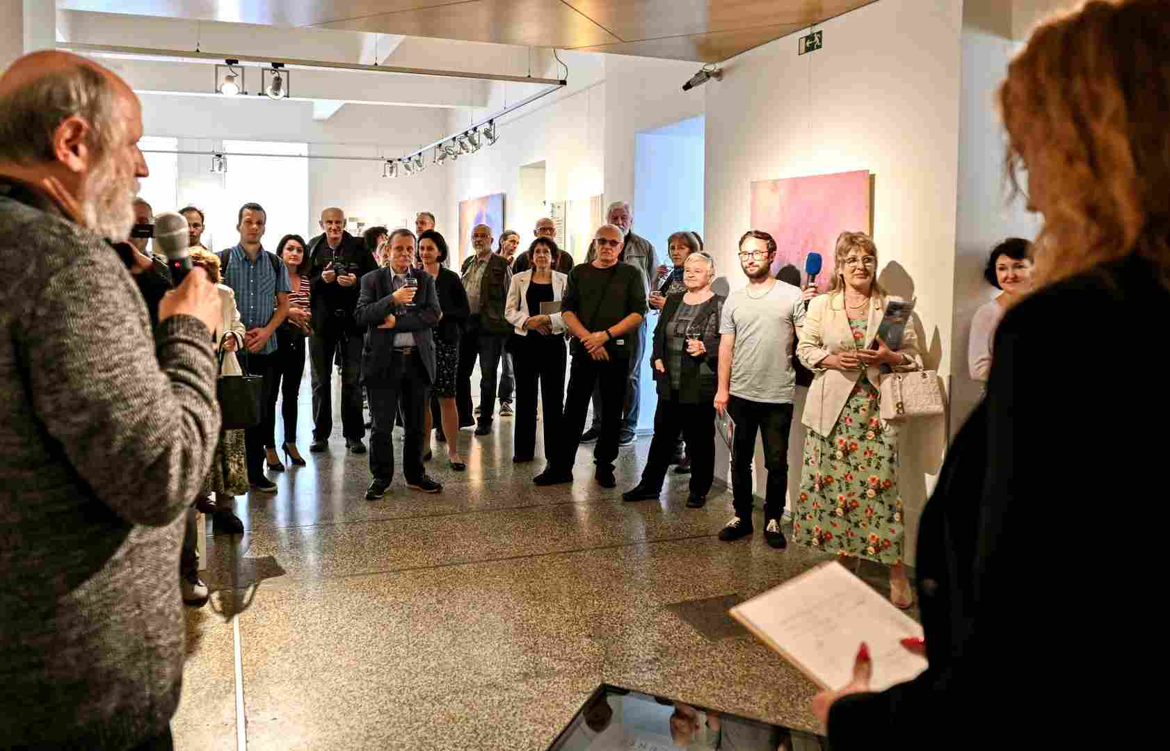

Opening of the exhibition EQUILIBRIUM - The Search for Balance - Silesian Ostrava Gallery Ostrava 2024

Last year's festival, in the form of Interviews, commemorated the life and work of such composers as Ivana Loudová, Ilja Hurník, Jan Novák, Milan Slavický.

A total of nine Interviews took place as part of this year's thirty-fifth year of Forfest. All but three were memories of personalities who have already left us. They include Miloslav Ištvan, Jiří Matys, František Emmert, Alois Piňos, Josef Adamík, Ilja Zeljenka. Three composers came to talk about their fates and their compositional work in person: Vít Zouhar, Jan Grossmann and Jan Vrkoč.

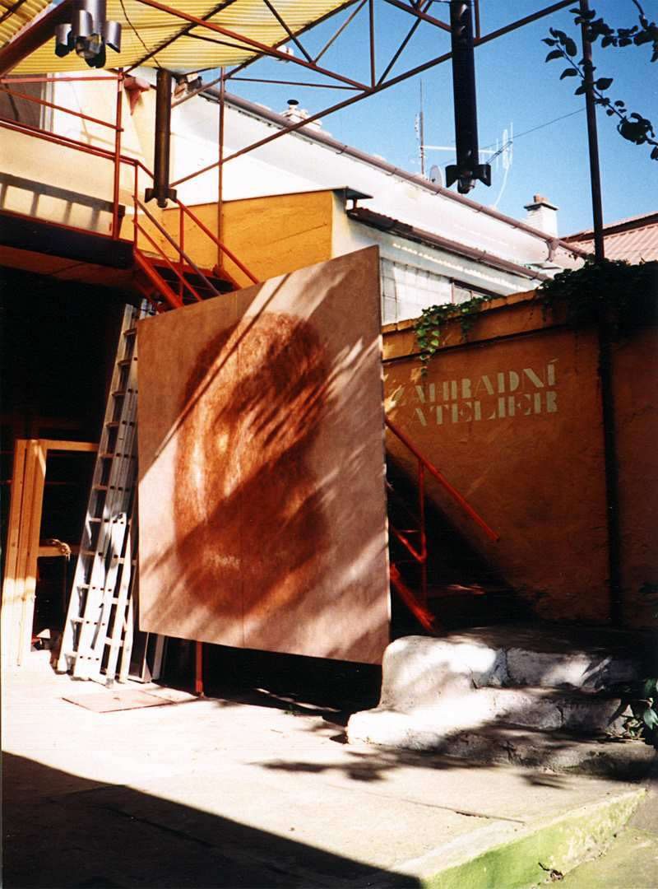

Garden Studio

1. Lectures

This year's Forfest Kroměříž included two lectures. The first was prepared by Ivan Bierhanzl and took place on Saturday, June 22nd in the afternoon at the Kroměříž Museum. The speaker presented the life and artistic work of the distinguished Czech conductor and composer Karel Ančerl. He particularly recalled the war years, when he was cruelly persecuted as a Jew along with other members of his family. He was the only one who survived. After Rafael Kubelík went into exile, he was the conductor of the Czech Philharmonic for almost two decades.

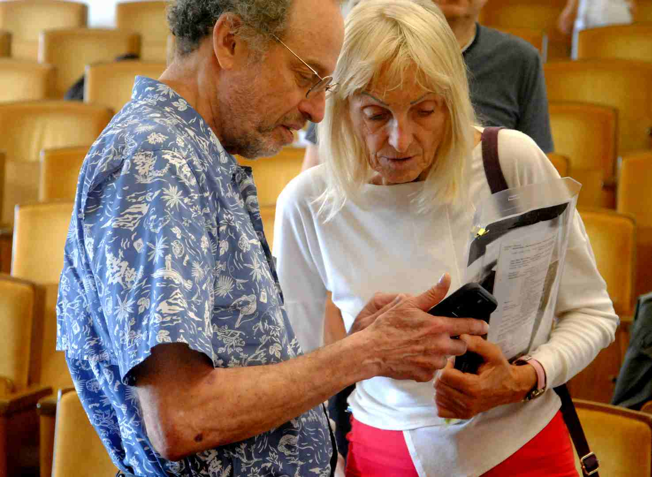

Colloquium 2024 - Dr. Laurence Sherr - USA, Doc. PhDr. Elena Leňanová - Slovak Republic

American musicologist and composer Laurence Sherr spoke on Sunday, June 23, in the lecture hall of the Museum of Kroměříž on another painful topic from the war history of the mid-twentieth century. His lecture was entitled Heroes of the Holocaust: Resistance in the Terezín Ghetto. He focused in particular on the fates of composers Hans Krása and Viktor Ullmann. On that occasion, he also presented his own compositional work. His composition Elegy and Vision for cello was inspired by the Holocaust and was performed by Czech violoncellist Štěpán Filípek.

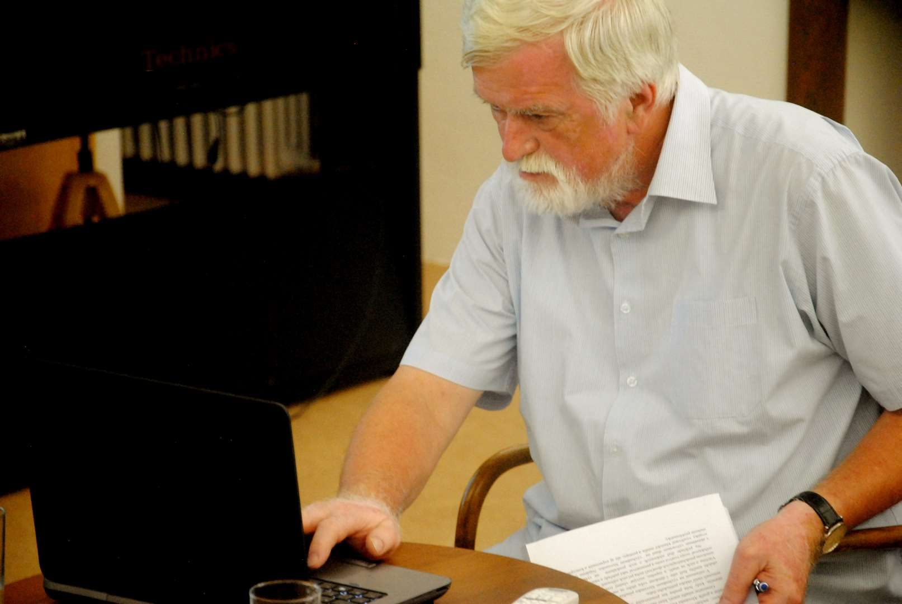

Colloquium 2024 - Doc. Vladislav Grešlík, ArtD. /Slovak Republic/

1. Colloquium - <https://www.forfest.cz/colloquys>

In a two-year cycle, international colloquiums are held within the framework of Forfest in Kroměříž, where musicologists, art theorists and publicists report on topics related to the idea of ​​the festival – Spiritual Currents in Contemporary Art. The specific assignment for this year was: Specifics of the perception of contemporary art.

During the three days from June 23 to 25, a total of 20 contributions were heard in the lecture hall of the Museum of Kroměříž. In printed form, they are included in a voluminous collection, which was subsequently published under the title of Forfest 2024

<https://www.forfest.cz/files/article-pdf/Kolokvium%202024%20final.pdf>

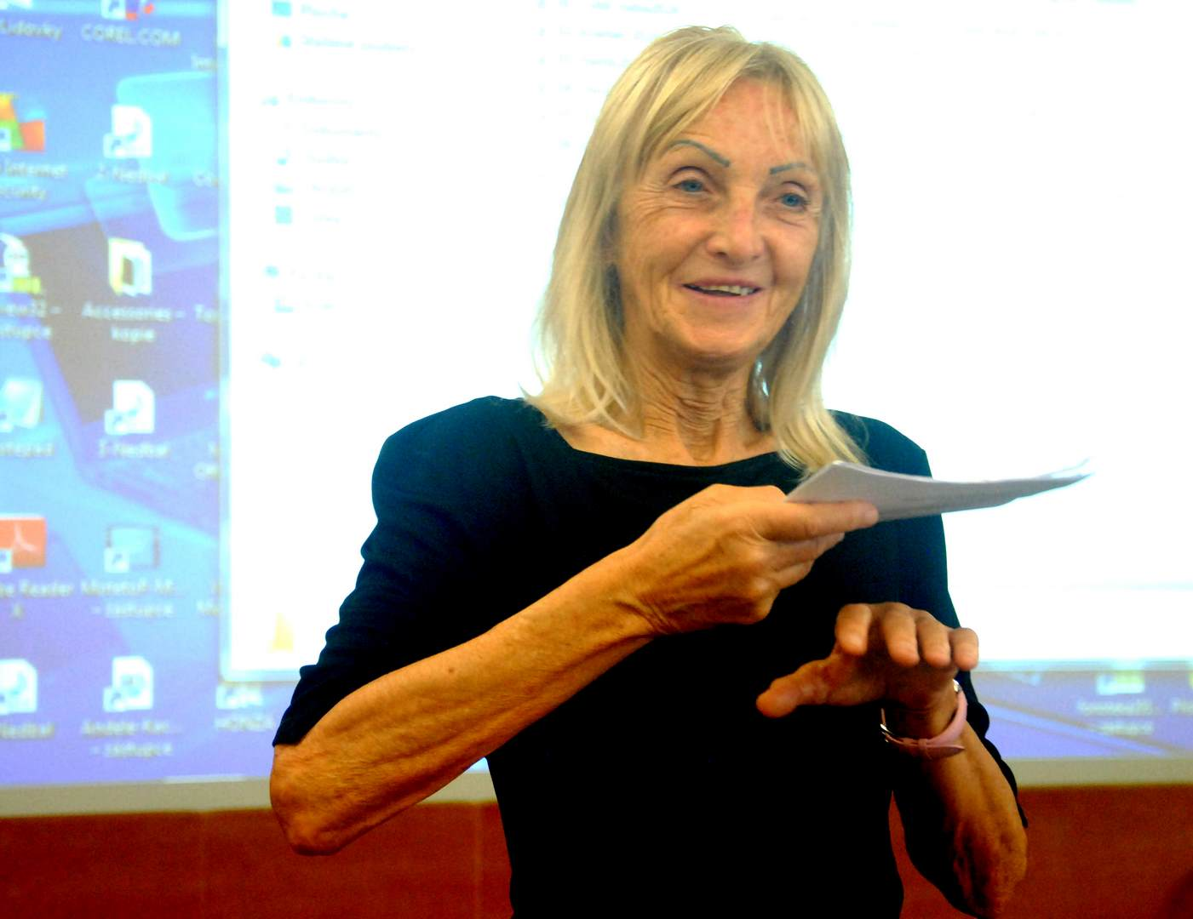

Kolokvium 2024 - Doc. PhDr. Elena Leňanová - Slovak Republic

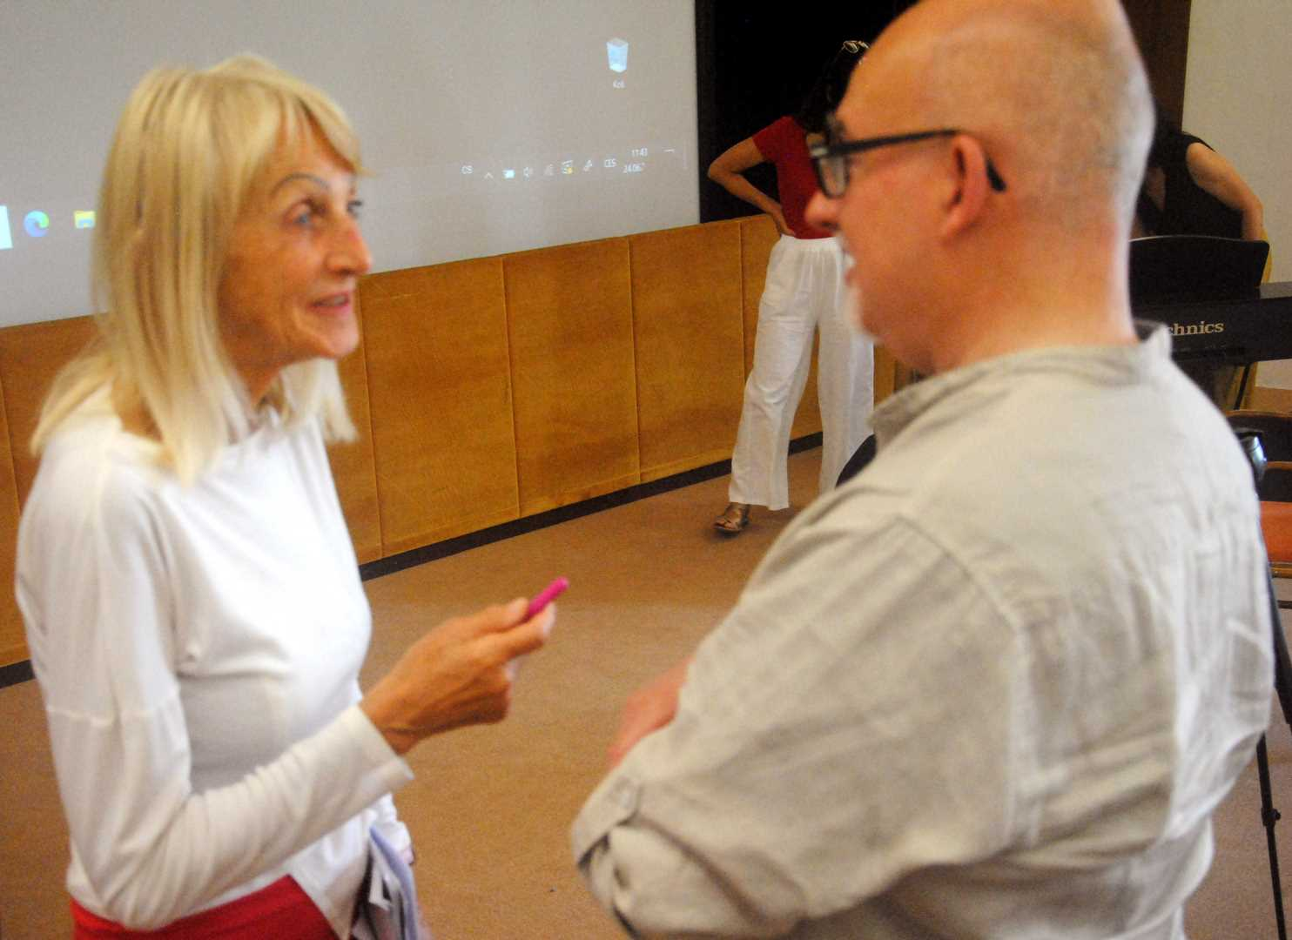

Kolokvium 2024 - Prof. Massimiliano Messieri - San Marino